

WHAT’S IN YOUR AUGUST 2022 MONKTON NEWS
Page
1 | Contents / Who Does What / Thanet Food Link
2 | Useful numbers and contacts
3 | Village hall diary and charges
4 | Editorial
5 | Farewells / Quiz Poster
6 & 7 | Parish Council News
8 & 9 | Church News
10 | Viewpoint Diana Davies
11 & 12 | Patient Liaison Group
12 | Invitation to Peter Gausden’s 90th Birthday Celebrations
13 | Wordsearch / Recycling and Waste Collections
14 & 15 | Village Groups
15 | Wordsearch Solution
16 | Summer Fruit Drizzle Cake
17 | Monkton Nature Reserve
18 | Royal British Legion Events
19 | Thanet Age UK
20 | Proposals to Increase Council Tax
21 + | Advertising Section

WHO DOES WHAT IN MONKTON NEWS?

Editorial team: Gina Anzani, Rachel Horsburgh & Gilly O’Neill
Distribution Kay & Harry Horne tel: 823849 Email: shudy@talk21.com
Articles and letters for Monkton News should be sent to:

monktonnews@gmail.com

BY THE 19TH OF EACH MONTH.

THANET FOOD LINK

AT THESE PARTICULARLY DIFFICULT TIMES THERE ARE
FAMILIES THAT RELY ON OUR HELP AND GENEROSITY
PLEASE PLACE DONATIONS OF FOOD IN SHED
ADJACENT TO GATE
AT 153a MONKTON STREET
THANKS FOR YOUR SUPPORT
Further information from Kay or Harry Horne
823849/shudy@talk21.com
USEFUL NUMBERS AND CONTACTS

POLICE NON-EMERGENCY  101 | MINSTER DOCTORS’ SURGERY 821333. Out of hours call 111
CRIME STOPPERS  0800 555 111 | SOCIAL SERVICES  860000
PCSO Debbie Forsyth  60457@Kent.pnn.police.uk  or call 101 | MINSTER LIBRARY  03000 413131  Open: Tues 09.30-13.30; Thurs 12-17.00; Fri 10.00-16.00 & Sat 09.30-13.30
DOMESTIC VIOLENCE HELP  07926 842 183  www.domesticabuseservices.org | SOUTHERN WATER to report a leak 0800820999  Supply or sewage problems  0330 303 0368  Billing 0333 200 3015
MONKTON C OF E PRIMARY SCHOOL 821394 | RSPCA  0300 1234 999
THANET DISTRICT COUNCIL – for all department information www.thanet.gov.uk  577000 | Parish clerk – Sara Archer 821989  clerk@monktonparish.co.uk  www.monkton parish.co.uk
THANET DISTRICT COUNCIL  Planning 577591 | Dog warden and noise control  577580
THANET DISTRICT COUNCIL  Recycling and fly tipping  577115 | MONKTON VILLAGE HALL BOOKINGS  821439
QEQM HOSPITAL  225544  Outpatients appointments line  01227 868686 | MINOR INJURY UNITS  Kent and Canterbury Hospital  24 hrs 01227 864244  Estuary View, Whitstable CT5 3SE  8-8 daily 01227 284301
NEAREST POST OFFICE  Minster 821291 | Opening Times: Mon-Fri 08.00-17.30 (closed for lunch 14.00-15.00) Sat 09.00-13.00

The Editors accept all advertisements, articles and notices in good faith and actively encourage the support of local traders and services. However, we cannot be held responsible for the quality of goods or services offered. The Editors reserve the right to alter, omit or hold over copy as they see fit. Views expressed herein are strictly those of their author and do not necessarily agree with those of the Editors.

MONKTON VILLAGE HALL DIARY FOR AUGUST

DAY | TIME | EVENT | CONTACT
Sunday | 11.00-13.00 | Ballroom and Latin American Dance | Gordon and Pauline
Monday | 09.15-10.15  13.00-15.00 (2nd Mon of each month)  19.00 | Dance exercise  Gardening Club  Dog agility and behaviour training | Maggie  Sue Northrop 07759390223  Chris Paris Brown  01227 365381
Tuesday | 19.30  19.30 (3rd Tues of each month) | Adult table tennis  WI | Gilly Brown  Penny Coleman 821539
Wednesday | 10.00-12.00  19.00-21.00 | Retired villagers’ social morning  Line Dancing | Sara Archer  821989  Theo Loyla 833643
Friday | 14.00 | Chairbased Exercise with Thanet Age UK | Rebecca Nicks 223881
For further information contact Pete Mitchell, 821439. If your club or activity is not in this month’s diary, please contact your organiser.

Monkton Village Hall Hire Charges 2022

Children's Party
Any Four Hours before 18.00 £45
This allows for the preparation and time to clean.
Part Day Hire
A Minimum of Two Complete Hours £30
All Day Hire up to 18.00
Includes Ten Complete Hours £100
Extra will be £15 per hour
All Day and Evening Wedding etc.
From 08.00- 23.00 £160
Also allows for full kitchen use & two hours the following day before
10.00 hrs for a return to clean.
Evening Hire from 19.00h
Quiz, Craft, Dance, etc. £40
Party Night from 19.00 £70
One dance couple 2 HOURS £10

EDITORIAL

Wow, it’s been a hot July – I hope that you all managed to keep cool and felt some sea breeze. Enjoy the Bank Holiday Monday at the end of the month.

August is usually a quiet month in the Village with many residents going off on their holidays. Before you go double and triple check doors and windows and make sure you cancel any milk deliveries. Ask someone to regularly check on the house and remove any mail from behind your front door. Consider investing in light timers. Apparently, if you were to suffer a break-in while you were on holiday and you had not secured your home properly, your insurance could be deemed invalid.
If you are lucky enough to be going abroad, it’s important to contact your bank to let them know if you want to use your debit or credit card while you are away. This is because any sudden overseas activity can cause them to become suspicious and without warning your card could just be stopped. Also be sure to take an emergency phone number to contact them, just in case.

£20 & £50 reminder (again)
Don’t forget to find all those paper £20 & £50 notes before the 30th September.
I’ve repeated what I wrote in the April edition:
‘The Bank of England will be withdrawing legal tender status of the paper £20 and £50 notes after 30 September 2022 and are encouraging anyone who has these at home to spend them or deposit them at their bank or Post Office. After 30 September 2022 people with a UK bank account will still be able to deposit withdrawn notes into their account. ‘

Congratulations
Congratulations to Rose and Tony who are to marry in St Mary Magdalene Church, Monkton on 20th August. Rose and Tony have lived in our village for 13 years and have 2 daughters, Amelia and Elysia. They’ve been together for 19 years. Tony proposed to Rose on their 15th year anniversary – he said that he had to ‘make sure’. Not good to rush these things is it, Tony! They were due to get married in 2020 but had to postpone it due to Covid. We wish them all the best in their marriage and hope they live happily, ever after.

Sad News
Unfortunately, we have lost 3 of our residents recently, Vera Gibbons, Dr John Semple and Reverend Dr Hugh Bird. Tributes to them can be found on the following page and on p.9.
FAREWELLS

Vera Gibbons
Our dear friend and Messy Church helper passed away on the 25th of May. Vera will be sadly missed by all her friends at Messy Church where she was fondly known as the ‘Glitter Queen’. Vera also helped with the ECO Warriors, nothing ever being too much trouble. Rest in Peace Vera.
Messy Eileen and Team

Dr John Semple
A sad farewell to Dr John Semple who passed away on the 10th June. He was the local Doctor in Minster for over 30 years and was a very popular and dedicated GP. He moved here, to Monkton Manor with his wife Judy and will be missed by his family, friends and all those whose lives he touched and assisted.

Saturday September 10th— 7.00pm

St Nicholas Manor Hall.

£5 each, bring nibbles and drinks.

Raising Funds for charity ‘Stand By Me’.

Raffle proceeds to be donated to
‘St Mary Magdalene, Monkton’ church.

To book please call 07871156204
PARISH COUNCIL NEWS

PLAY AREA CLOSURE DURING AUGUST
We would like to remind you the Play Area will be closed for around 3 weeks in August. This is to allow time for the existing equipment to be taken out and the new play area installed. The exact start date has not yet been confirmed, but as soon as we are informed, we will let everyone know via the Village Notice Boards and Facebook.
It is, of course, regrettable that the installation date falls during the school holidays! Unfortunately, we were unable to alter this as we had to work around equipment supply and contractors’ availability. We hope any inconvenience to villagers is minimal and look forward to welcoming visitors to an exciting new play area at the end of August.

BUS SERVICES IN MONKTON CHANGED OR AXED
We were surprised – in fact we were shocked! – to learn recently of the changes that are being made to bus services affecting Monkton. These come into effect on AUGUST 28TH.
* The no 11 route will no longer run.
* The no 9 will take over from the old 42 route, starting at Monkton and going to Ramsgate via the Nethercourt Estate. There will no longer be a service to Canterbury or Broadstairs on this route.
* The 9X bus will still run but with a limited timetable at peak times.
Details of all timetables will not be available until August, so exact details are yet to be revealed.
These changes will leave Monkton with an extremely limited bus service and other villages (Preston and Stourmouth) without any service at all! Almost all areas of Thanet will be less well served in a time when we are supposed to be promoting sustainability and non-reliance on the car! We feel these cuts make something of a mockery of current policy.
As a Parish Council we will therefore be campaigning against the changes. We are also actively liaising with other local Parish Councils with the idea of creating a stronger, collective voice to challenge the decision.
If you wish to personally object, please make your views known to Stagecoach customer.services@stagecoachbus.com (who are implementing the cuts) and KCC county.hall@kent.gov.uk (who are withdrawing the subsidies which allowed these routes to operate). You may also wish to copy Sir Roger Gale galerj@parliament.uk in on any correspondence.
To give us an idea of the size of objection in the village, we would be grateful if you would copy us in as well. Thank you.

PLANNING
We understand a decision on the Heyhill Appeal is due shortly. We have not been given any indication as to how the decision will go, but we will, of course, keep villagers fully informed as soon as we are notified.

THE QUEEN’S JUBILEE GREEN CANOPY SCHEME
Just to jog your memory about this scheme …. the Parish Council are joining in the national tree planting scheme to mark and celebrate the Queen’s Platinum Jubilee Year.
We will shortly be contacting all Groups and Clubs in the village inviting them to plant (and look after!) a tree at the Recreation Ground. We will also welcome individual

PARISH COUNCIL NEWS - continued

villagers, or families, who wish to join in the scheme … you may wish to plant a tree in memory of a loved one or just have a tree that you can call your own!
We do have a small pocket of grant money to help those who might struggle with the cost of buying a tree …. please feel free to contact Sara, as below, for further information on this.
We will be coordinating the actual plating of the trees around November time and will log all trees in the scheme and add these to existing records.

HIGHWAYS ISSUES
SPEED INDICATOR SIGNS - we have contacted KCC Highways again about their removal of the speed indicator signs that were on the verge outside the new development adjacent to Walters Hall Farm. We have reiterated the importance of these signs for the village and the issue of speeding along Monkton Street. They have confirmed they will look at the possibility of reinstating them, but cannot do so until the development is finished.
‘NO THROUGH ROAD’ SIGN – we have requested a ‘no through’ road sign for Seamark Close to stop traffic using it to access the Rec Ground. We have been informed this should be installed over the next couple of weeks.
WILLETTS HILL – we are still waiting for a response from KCC Highways on what can be done about the erosion at the side of the road and resulting mud & debris run-off in heavy rain.

FLOODING ISSUES
SOUTHERN WATER has recently installed non return valves to 4 properties along Monkton Street which have been affected by sewage flooding.
In addition to repairs to cracks and blockages in the main sewage drain running through the village, it is hoped these measures will now ensure sewage flooding does not reoccur in the village.
BLOCKED DITCH BEHIND SEAMARK CLOSE along Rec Ground access track – we are pleased to report agreement has now been reached regarding the clearing and future maintenance of this ditch which has caused long term flooding issues in Seamark Close.
KCC Highways have carried out various repairs to the drain network in the village and have also jetted the main village drains including those in Willetts Hill, Seamark Close and the storm drains that discharge into the ditch. Again, it is hoped the combination of all these works will solve the flooding issues in Seamark Close and the middle section of Monkton Street.

COUNCILLOR VACANCY
Applications for the vacant Councillor position close on July 22nd. We are pleased to have received interest in the vacancy and look forward to announcing our new Councillor in the September Newsletter.

NEXT MEETING Monday 5th September, 7pm in Monkton Village Hall
THERE IS NO PARISH COUNCIL MEETING IN AUGUST.

Contact the Parish Council via Sara Archer
clerk@monktonparish.co.uk 01843 821989
www.monktonparish.co.uk

CHURCH NEWS

The Parish Church of St. Mary Magdalene, Monkton
We are part of the Wantsum Benefice which comprises the Church of England Parishes of Minster, Monkton, St. Nicholas-at-Wade with Sarre, & Chislet. (Together with All Saints, Birchington, Minnis Bay, Acol & St. Saviour’s, Westgate we form the Seamarsh Group of Parishes).

Vicar of the Benefice | Vacant
Benefice Administrator | Mrs Sheila Greenstreet | 077887 91468
Licensed Lay Minister | Mrs Sally Willins | 822428
Churchwarden (Monkton) | Mr David Mairs | 079604 17493
Retired Priest (assisting) | Canon Peter Gausden | 825374
Reader Emeritus | Mrs Diana Davies | 823017
On Line Contact: info@wantsumchurches.org www.wantsumchurches.org

To make any general enquiries, or to arrange a Baptism, Wedding or Funeral, please contact the Parish Administrator, Mrs Sheila Greenstreet (077887 91468 or info@wantsumchurches.org).

If you wish to talk to someone, need support or would welcome prayer please contact: Mrs Sally Willins Telephone: 822428

Wantsum Benefice Services – AUGUST 2022

 | Monkton | Minster | St Nicholas | Chislet
Sun 7 August Trinity 8 | 9.30 Holy Communion | 10.30 Holy Communion | 10.30 Village Worship
Sun 14 August Trinity 9 |  | 10.30 Morning Worship | 10.30 Holy Communion | 9.30 Holy Communion
Weds 17 August |  | 10.30 Holy Communion
Sun 21 August Trinity 10 | 9.30 Holy Communion | 10.30 Holy Communion | 10.30 Morning Light
Sun 28 August Trinity 11 |  | 10.30 Morning Praise | 10.30 Holy Communion | 9.30 Family Praise
Sun 4 September Trinity 12 | 9.30 Holy Communion | 10.30 Holy Communion | 10.30 Village Worship

Please check Village notice boards and/or the Benefice web site for any developments and changes.

Forthcoming Weddings at St. Mary Magdalene, Monkton
On 20th August 2022 at 3pm
Tony David Alfred Betts and Rose-Marie Lake
On 24th September 2022 at 3 pm
James Philip John Edwards and Laura Elizabeth Horsburgh
CHURCH NEWS - continued

Sunday Bible Readings in August

7th Trinity 8 Hebrews 11, 1-3 & 8-16; Luke 12, 32-40

14th Trinity 9 Hebrews 11, 29 -12, 2; Luke 12, 49-56

21st Trinity 10 Hebrews 12, 18 – end; Luke 13, 10-17

28th Trinity 11 Hebrews 13, 1-8 & 15-16; Luke 14, 1 & 7-14

The Revd. Dr Hugh Bird
22.9.1924 – 23.6.2022
Hugh Bird read medicine at Cambridge then moved to St Thomas’ Hospital where he met a young nurse, Ann Gough. Following military service with the RAF, Hugh & Ann were married at Highgate in 1952.
In 1951, Hugh joined a General Practice covering Sutton Valence, Boughton Monchelsea, Linton and Coxheath and in 1955, He & Ann set up home in Linton where they raised their family of three children, Edward, Lucy and William. Edward was tragically killed, aged 22, in a farming accident in 1976.
As retirement approached, Hugh trained for the Church of England Ministry at Cambridge and was ordained priest in 1986, serving as a non-stipendiary minister in his home parish.
It was in 1995 that Hugh & Ann came to live at Slate Barn, Seamark Road, next door to their daughter Lucy, now married to Robert Montgomery. Hugh was invited by the then Priest-in-Charge, Bob Coles, to take responsibility for St. Nicholas-at-Wade, within the Wantsum Group of Parishes. So began a dedicated & caring ministry, with the able assistance of Ann and Lucy in work among the children.
Hugh was still a practising Doctor, and for some years helped as a locum in Thanet practices. Within the Church Hugh assumed a number of roles – including collating the parish magazines for Monkton & St Nicholas and taking a turn at mowing Monkton Churchyard, transporting his own mower by trailer.
In 2004, aged 80, Hugh decided to officially retire from his licensed post at St. Nicholas and he and Ann became members of Monkton congregation. Here, Hugh often helped with Sunday services whilst proving a wonderful guide and stimulus in the monthly Bible Study group.
Well versed in the Classics, Literature and History, as well as medicine, and with some very down to earth theological views, Hugh’s breadth of
scholarship was enthralling. His ability to put things across with simplicity, and always with humour, meant that our group might often be located by the sound of its laughter! Hugh was still leading sessions with the group up to the time of the Covid outbreak in 2020.
Following Cremation at Thanet on 19th July, a Thanksgiving Service was held in St Nicholas’ Church.
----------------------------------------------------------------------------------------

VIEWPOINT

Pastoral Reflection from Diana Davies: Reader Emeritus to the Wantsum Benefice

Dear friends,
Who do you think you are?
As I write my mind is filled with the story of Mo Farah, who courageously decided to explore the questions of his true identity and of how he came from Somalia to live in the UK gaining British citizenship and winning Olympic gold for his adopted country.
I won’t repeat his true story here as I am sure most of you will have seen the tv programme or read accounts of it. Suffice to say it was far from the fairy tale which had gradually been built up around him. He had to face some painful truths and even risk deportation and being parted from his lovely wife and their children. Yet deep down he felt compelled to find his birth family and show his son where he had come from.
Now that stories of children of unmarried girls in the 1950’s and 60’s (often taken away a few days after they were born) can be told and siblings reunited it has become plain how important for them to discover the circumstances of their birth in spite of the fact that many had been adopted into loving families.
Today we have heard that a Van Gogh canvas has revealed a hidden self portrait of the artist which may shed more light on his often troubled life
Perhaps, like me, you have sometimes hit the wrong button on your tablet when raking a photo and been shocked at seeing your own face, quire unprepared, ..a salutary experience! It makes me realise how much I prepare my expression before I look in the mirror!
St. Paul writes that our perception of who God is and his love for us is, in this life like a reflection in a flawed mirror ..one day ( and sometimes fleetingly in our everyday life) he tells us we will see Him clearly with the eyes of our hearts face to face.
Diana

MINSTER SURGERY PATIENT LIAISON GROUP



COVID-19 VACCINATION PROGRAMME – REMINDER
The Vaccination Centre is located adjacent to Wickes Building Supplies and Curry's Electrical Store. It is known as Thanet Broadstairs Local Vaccination Service (LVS). Please note change of opening times – now open every Tuesday & Thursday from 2pm to 6.30pm, every Saturday from 8am to 2pm. Drop in, no need for an appointment.
Please remember you must wear face masks at the Centre and at Minster surgery.
PLEASE NOTE:
With the surge of covid cases due to the more infectious strains of Omicron, if you're thinking of travelling abroad, check with your travel company for the Rule changes being introduced by other countries and airlines.

“LET’S BE CLEAR ON CANCER” NATIONAL CAMPAIGNS:
CERVICAL SCREENING AWARENESS CAMPAIGN
Did you know? Cervical Cancer is the most common for those under 35
On average two women die each day in the UK
For further information search:
www.macmillan.orgukcancer/cervical-screeing-awareness

IT’S HOLIDAY TIME!
With the start of the school holidays families are now planning holidays at home or abroad, so please ensure you have sufficient medication for all the family to last you. Also please take into account that our healthcare professionals also take family holidays and allow sufficient time when submitting your prescription requests, both at the Surgery and at the various Pharmacies.
Requests submitted prematurely will be held until the due date, unless a specific reason is given.
THANK YOU

Don’t forget you can get help and advice and make sure your travel Vaccinations are up to date from your local Pharmacist.

MINSTER SURGERY PLG - continued

SURGERY CLOSURE DAYS
Please note that the surgery will be closed on Thursday 25th August from 1pm onwards for staff training and on Bank Holiday Monday 29th August.
If you need to see a Doctor during these times:
Please Call 111 for NON URGENT confidential help and advice for you and your family.
For COVID-19 help and advice - Call 119
For URGENT/LIFE threatening Cases Call 999 as normal

PATIENT LIAISON GROUP
A full list of all Committee Members with their contact information is shown on our Notice board in the waiting room.
Please don’t forget we are always here to help and support you and you can contact us anytime, by phone or email at kenself@me.com

Our next meeting will be held on Monday 1st August and if you have any questions on any of the above or concerns and suggestions you would like raised at our meeting, please contact: Ken Self on 821200 or Jeanne Lawrence on 821049 or email kenself@me.com

Come and Celebrate

Peter Gausden’s
90th Birthday

Sunday September 11th
2:00–5:00pm
Everyone is welcome to ’Afternoon Tea’ at 2 Millers Lane.
Please let us know if you would like to join us: by calling either (01843) 822763 or (01843) 825390 by August 20th.
WORDSEARCH

R | O | Y | A | L | E | X | C | H | A | N | G | E | D | F | E | V | G
L | E | P | Z | V | W | Y | P | C | B | M | O | L | W | Q | N | I | Q
X | Z | C | B | N | L | P | L | A | Y | G | R | O | U | P | E | C | P
Q | U | O | R | I | J | H | F | V | M | D | E | P | X | B | L | A | V
W | H | I | T | E | S | T | A | G | X | Q | S | S | Y | M | A | R | N
I | T | U | I | P | A | K | L | C | B | P | T | R | V | S | D | A | R
L | X | S | K | C | O | T | S | V | T | Y | R | E | B | D | G | G | M
L | X | W | R | T | Y | O | I | P | M | N | E | T | V | R | A | E | B
E | S | V | C | B | N | P | W | O | Q | N | E | N | M | A | M | G | H
T | U | R | K | E | Y | R | N | L | N | X | T | U | Z | L | Y | A | C
T | P | Z | Q | B | M | K | D | L | V | G | C | H | P | L | R | R | R
S | F | W | P | Q | S | J | D | A | P | O | R | X | I | O | A | D | U
H | X | Z | T | W | Q | P | W | H | K | P | Q | O | X | C | M | E | H
I | U | P | A | L | N | B | C | E | V | Q | O | F | U | U | T | N | C
L | S | L | S | P | Q | W | P | G | J | H | Q | B | X | N | S | Z | T
L | L | P | A | R | S | O | N | A | G | E | F | I | E | L | D | S | S
P | Q | N | V | X | A | S | Q | L | M | C | R | E | L | P | K | J | I
D | R | A | H | C | R | O | D | L | O | P | Q | G | O | D | L | A | D
G | R | T | W | C | X | P | W | I | M | C | U | P | O | E | W | O | O
P | Z | U | W | L | G | L | E | V | O | R | D | E | H | T | W | P | H
F | A | R | M | P | C | B | A | L | S | Q | S | P | C | T | Y | N | T
Q | Z | E | S | O | L | C | K | R | A | M | A | E | S | Q | P | X | E
T | R | E | S | E | R | V | E | N | A | L | S | R | E | L | L | I | M

Find these Monkton words in the grid:
Collards Old Orchard Stocks
Foxhunters Parsonage Fields The Drove
Gore Street Playgroup Turkey
Methodist Church Recreation Ground Farm
Millers Lane Royal Exchange Vicarage Garden
Monks Wall School Village Hall
Nature Seamark Close White Stag
Reserve St Mary Magdalene Willetts Hill

RECYCLING AND WASTE COLLECTIONS FOR AUGUST

Make sure that your bins are out by 7.00am to ensure collection.

Monday 1st August – Green bin (garden waste)
Friday 5th August – Blue recycling bin and red bag for paper
Friday 12th August – Black bin (general waste)
Monday 15th August – Green bin (garden waste)
Friday 19th August – Blue recycling bin and red bag for paper
Friday 26th August – Black bin (general waste)
Monday 29th August – Green bin (garden waste) – although this is a Bank Holiday, according to Thanet District Council’s website, this shouldn’t affect collection
VILLAGE GROUPS

WEDNESDAY MORNING SOCIAL CLUB

Twenty-one of us enjoyed a lovely barbecue at our Wednesday morning club on the 13th July.
We couldn’t get Malcolm to be our naked chef, but he did a marvellous job despite the heat, many thanks to him. A few of us braved the temperatures to sit outside, but the sensible ones ate their lunch in the cool of the Village Hall.
Our Wednesday social club for the retired and semi-retired villagers of Monkton is held each week from 10am to 12 noon. You are welcome to drop in for tea or coffee & a slice of cake. It’s an informal club where we chat with other villagers and you can join in with a board game or cards.

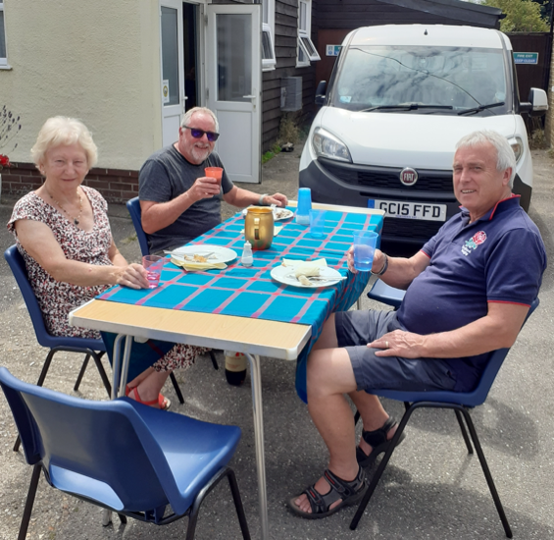
So, if you are at a loose end on a Wednesday morning, please come and join us. If you need further information, please contact Sara Archer (821989) or Gilly O’Neill (821232).

MONKTON GARDEN GROUP

On one of the hottest days of the year at our last meeting we welcomed
several new members to the club and had a record attendance.
Philip Oostenbrink (Head Gardener at Walmer Castle) talked about the history of the castle and gardens. Philip’s own garden will be opening soon as part of the National Garden Scheme.
Our bring and buy sale went well and thank you to all those who helped.
Sam Brown put out the tables and chairs for us - thank you Sam and we would like to thank Del and Pete for opening the windows and drawing the curtains keeping us cool.
Our next meeting will be at 1 pm in the Village Hall on Monday 8th August - £3 with Jean Griffen from Radio Kent’s Sunday Gardening programme.
VILLAGE GROUPS - continued

Jean will be giving us “Tales from the Potting Shed”. This will be our first year anniversary and we will be having cake and snacks to celebrate.
Please bring along a small contribution and also we will hold another flower arranging competition. “Flowers from your own garden” either a posy or an arrangement. Jean has promised to judge this for us and there will be a small prize.
We welcome newcomers - no membership required just come when you can.
Visit our Facebook group “Monkton Garden Club” or contact me
Sue Northrop 07759390223

WORDSEARCH SOLUTION

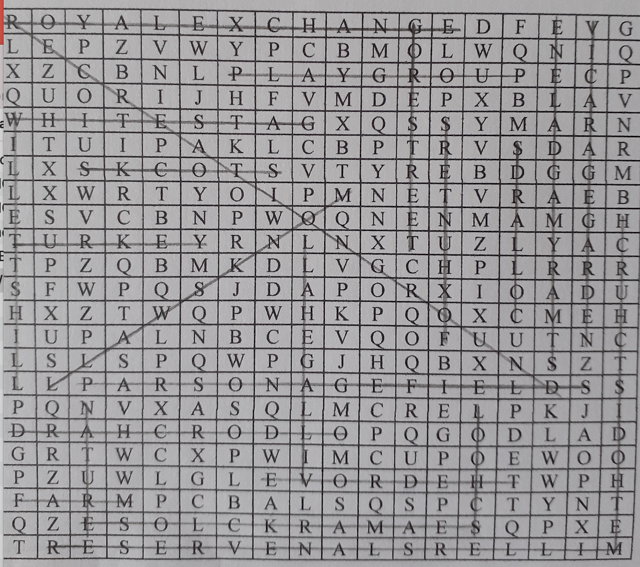
Summer Fruit Drizzle Cake

With the glut of glorious summer fruits around – here’s an easy recipe for you to try. You can choose which fruit to use – try blackberries (halved), apricots (diced), blueberries, nectarines or peaches (diced), raspberries (my favourite), plums (diced), redcurrrants/blackcurrants or strawberries.

175g/6oz very soft butter
175g/6oz golden caster sugar
250g/9oz self-raising flour
2 eggs
1 teaspoon vanilla extract
175g/6oz fruit, stoned weight – see above
100g granulated sugar
1-2 tablespoon citrus juice (lemon, lime or orange) as necessary

- Heat oven to 180°C/160°C fan/gas 4. Grease a 900g/2lb loaf tin and line the base and ends with a long strip of baking paper. Put the butter, sugar, flour, eggs and vanilla extract into a large bowl and beat with an electric hand mixer for 5 mins until pale and creamy – the mixture will be very thick.
- Spread one- third of the cake mix into the tin, then scatter over 50g of the fruit. Carefully dot and spread another third of the cake mix on top, and scatter with another 50g fruit. Finally, dot the rest of the cake mix over and gently spread with the back of a spoon. Bake for 1 hour until an inserted skewer comes out clean. I usually cover with foil halfway through cooking time, to prevent over-browning.

- Poke the cake all over with a skewer. Put remaining 75g fruit into a bowl with the granulated sugar. Stir in 1 tablespoon of the citrus juice first with a fork, mashing a little of the fruit as you go. If it’s a bit dry, add a splash more juice and spoon over the centre of the cake in a long strip down the middle. Leave in the tin until the cake is cool and the topping is set and crisp.
MONKTON NATURE RESERVE

RESERVE AND NATURE TRAILS - ENTRANCE FEE APPLIES FOR NON-MEMBERS
NATURAL HISTORY MUSEUM
SECONDHAND BOOKSHOP - DONATIONS WELCOME
THE CABIN CAFÉ
NATURE SHED PROJECT

Open Saturday, Sunday, Tuesday & Thursday 10.30-3.30pm
Web site: https://monkton-reserve.org/
Tel: 01843 822666 Email: contact@monkton-reserve.org

EVENTS IN AUGUST

Tuesday 2nd – Pond Dipping (11am), Big Bug Hunt (1pm)
Thursday 4th – DIY ‘Nature Glitter’ (11am), Pond Dipping (1pm)
Tuesday 23rd – Pond Dipping (11am), Nature Tales and Toys (1pm)
Thursday 25th – Big Bug Hunt (11am), Butterfly Buddies (1pm)

Price per child: Members £3, Non-members £5 (includes reserve entry)

How to book: email education@monkton-reserve.org

Registered Charity – Thanet Countryside Trust 285972

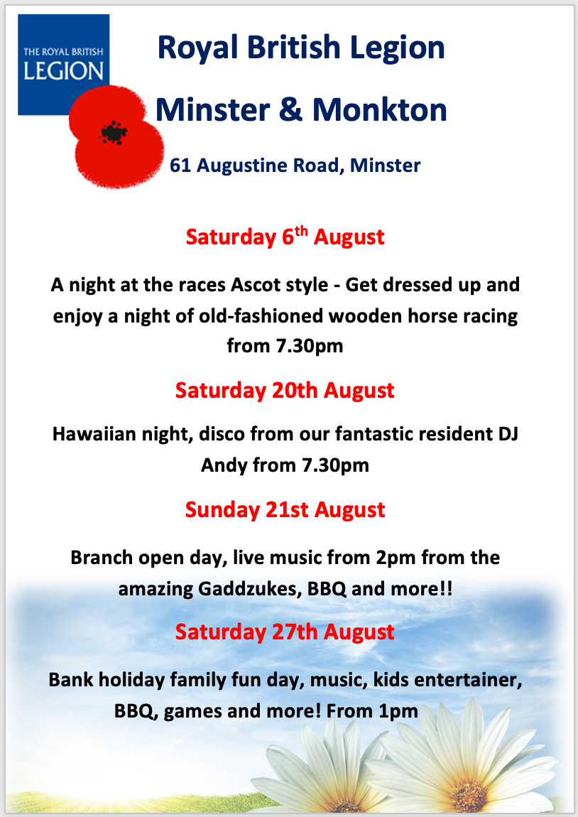


Proposals to Increase Council Tax
Kent County Council (KCC) is launching a seven-week consultation, asking residents for their views on our proposals to increase Council Tax to help fund vital services and their ideas for making further savings.
In the absence of any additional funding from central government, we are considering an increase in next year’s Council Tax up to 3% and a reduction in spending on council services.
Peter Oakford, Cabinet Member for Finance, Corporate and Traded Services, said: “It’s an incredibly difficult time for all of Kent’s residents and KCC faces exactly the same amount of pressure. We see inflation and the cost of living rising and the fuel price increasing, higher than they have ever been. All of this impacts on KCC’s budget just as much as it does our own personal expenditure.
“KCC has faced huge challenges in recent years and has already had to make over £810 million pounds worth of savings since 2010. We already know the government doesn’t intend to provide any additional funding to us next year, so we have to make do with the money we’ve got. The only area where we can increase our funding is through Council Tax which of course isn’t something we want to do but during the current situation we could be forced to do it.”
Work to prepare our new budget typically starts in March. An essential element now the numbers are crunched is providing residents with the financial picture and asking them for support in the next stage of the decision-making process.
Peter Oakford added: “We urge everyone to take part in the consultation and to have their say. It’s an important process which is fundamental in informing how this budget is shaped.
“We have an annual budget of £1.8 billion which does sound like an enormous amount of money but then you look at the services that KCC provides it doesn’t go very far.
“We need to know from our residents their views on increasing Council Tax to partly help meet rising costs and demand for our services. Even with an increase in Council Tax, some new savings and additional income would still be needed to balance our budget. We therefore also want to hear their ideas for where they think that perhaps we could make some further savings and where those savings would have the lowest impact to our communities.”
How do people get involved?
The consultation runs until 5 September 2021. To take part, please visit our website www.kent.gov.uk/budget.
Consultation responses will help inform decisions ahead of the publication of the detailed draft budget proposals in early January 2023 and will then be considered by Councillors at their Cabinet Committee and Cabinet meetings taking place throughout January 2023 before the budget proposals are finalised and considered for approval by County Council in February 2023.

ADVERTISING SECTION

YEARLY ADVERTISING RATES

The printing of the magazine is no longer in-house.
Here are our annual rates:

Full page £90 Half page £45
Quarter page £25

All fees payable in advance – please make cheques payable to St. Mary Magdalene Church.
TO PLACE AN ADVERT CONTACT
monktonnews@gmail.com



COLE’S GARDENING SERVICES
Friendly and reliable lady gardener
Lawn cutting. pruning, tidying , hedge cutting
NO JOB TOO SMALL
CONTACT
07916740078 - ask for Carol
OR EMAIL
c.colegardening@gmail





SLM WASTE MANAGEMENT LTD.
THE STARTING POINT FOR ALL YOUR WASTE SOLUTIONS
KENT BASED AND ENTIRE UK COVER
ALL TYPES OF WASTE DISPOSAL SERVICE
- SKIPS AND RORO
- HAZARDOUS WASTE
- CHEMICALS, INKS

- CLINICAL WASTE
- PLASTICS
- CARDBOARD
- GENERAL WASTE AND RECYCLING

LET US DEAL WITH ANY TYPE OF WASTE OR HELP YOU WITH
FACILITIES MANAGEMENT
CONTACT: -
PHONE: 01304 775000 or MOB 07710503581
Email lucy@slm-waste.com

Support Network Services Limited
Business and domestic computer support, consultation and troubleshooting
Very experienced network engineers
Microsoft, Novell and Citrix qualified
Also Apple Mac knowledge
Variety of skills including installation, and repair of pcs, servers, printers wired and wireless networking and broadband
VIRUS AND SPYWARE REMOVAL
FRIENDLY LOCAL COMPANY, MONKTON
CONTACT 01843 822430
EMAIL info@supportnetwork.co.uk


All roofing works undertaken
Monkton village based
Re-Roofs - Flat, Tiled or Slate.
Roof Repairs Flat, Tiled or Slate
Repairs and Re-bedding of Hips, Valleys, Ridges and Verges
Vertical Cladding - Weatherboards, Cedar Shingles and Kent Peg Tiles
Leadwork & Chimney Repairs/Chimney maintenance
UPVC Fascias, Soffits & Guttering
Felt Support Trays/Felt Repairs
Velux Window Installation & Repairs
Roof space Ventilation and insulation
Bird Deterrents - Pigeon/Seagull Netting/Bird Spikes
CONTACT US
PHONE: 01843 838447 www.grasby-roofing.co.uk
Email: info@grasby-roofing.co.uk
The Pierson Cake Company
MONKTON, KENT
Cakes for all occasions
01843 319215
mobile 07530 857163
email Francesca_drake@hotmail.com
find me on FACEBOOK: -
The Pierson Cake Company

ANDREW PEALLING
PLUMBING CONTRACTOR

MONKTON BASED
EXPERIENCED AND RELIABLE
For a free quotation
Contact
OFFICE 01843 822244
MOBILE: 07789 242467

A
LERT PLUMBING AND HEATING

Plumbing
Boiler service and repairs
All plumbing and heating work undertaken – 24-hour emergency call out available
01843 265009
www.alertplumbing.co.uk
email : noel@alertplumbing.co.uk

- Main
- Potterton
- Baxi
- Alpha
- Vaillant
- Worcester
- Ariston and Bosch group

K.S.BRICKWORK
36 Hunting Gate, Birchington
For free quote and advice on
- Home extensions
- Garages
- Garden walls and patios
Call Keith: 01843 841488
Or mobile: 07745 401996



NP
ELECTRICALS
BS7671 QUALIFIED ELECTRICAL ENGINEER
ELECSA – part of the ECA GROUP
PART B REGISTRATION NO. EPP2390
All electrical work undertaken
*free quotations *Competitive prices *Quality workmanship
*Fully guaranteed
CALL NIC MORLING
07714 580 978
Serving the villages since 2005
www.npelectricals.co.uk

RACHEL’S D.I.Y. SERVICE
PAINTING, DECORATING, TILING
FLAT PACK FURNITURE
LADY DECORATOR
Free quotes and no job too small
Contact: 01843 822338
Email:- rachel@rachelsdiy.co.uk

GARY MOSS
CHIMNEY SWEEP
CONTACT 01304 271053
MOBILE
07928 230007
ICS registered member

R.B.W.
KENT’S WATER FEATURE AND POND BUILDING EXPERTS
Garden / pond design/ building and refurbishments/ pond cleaning/ maintenance/ maintenance contracts
Child safe pond covers
Filtration specialists
Patios – decking – fencing – brickwork – arbours
Tel: - 07563212858
Free estimates and consultations

www.ReflectionByWater.com
Email: andrewlongrbw@hotmail.com

SJG

HOME IMPROVEMENTS
- Refurbishments
- General building
- Domestic and commercial
- Kitchens and bathrooms
- Painting and decorating
- Carpentry sash windows
- Laminate and wood flooring
- Tiling, dry lining, coving
For a free estimate
CALL
01843 822191
MOBILE: 07966 495 804

sjghomeimprovements@sky.com
www. sjghomeimprovements.com





