


WHAT’S IN YOUR JUNE 2022 MONKTON NEWS
Page
1 | Contents / Who Does What / Thanet Food Link
2 | Useful numbers and contacts
3 | Village hall diary / Message from Brenda Graham / Editorial
4 | Monkton Open Gardens
5 | Monkton Church of England School News
6 | Arts & Crafts Display / Well done Sara
7 | Parish Council News
8 & 9 | Church News
10 & 11 | Viewpoint from Peter Gausden
11 | Minster Open Gardens / Minster Show
12 | The Wombles of Monkton
13 & 14 | Patient Liaison Group
14 & 15 | Village Groups
16 | Recycling and Waste Collections / Royal British Legion Events
17 | Monkton Nature Reserve
18 | Queen’s Platinum Jubilee Celebrations
19 & 20 | Platinum Jubilee Pudding Recipe
20 + | Advertising Section

WHO DOES WHAT IN MONKTON NEWS?

Editorial team: Gina Anzani, Rachel Horsburgh & Gilly O’Neill
Distribution Kay & Harry Horne tel: 823849 Email: shudy@talk21.com
Articles and letters for Monkton News should be sent to:

monktonnews@gmail.com

BY THE 19TH OF EACH MONTH.

THANET FOOD LINK

AT THESE PARTICULARLY DIFFICULT TIMES THERE ARE
FAMILIES THAT RELY ON OUR HELP AND GENEROSITY
PLEASE PLACE DONATIONS OF FOOD IN SHED
ADJACENT TO GATE
AT 153a MONKTON STREET
THANKS FOR YOUR SUPPORT
Further information from Kay or Harry Horne
823849/shudy@talk21.com
USEFUL NUMBERS AND CONTACTS

POLICE NON-EMERGENCY  101 | MINSTER DOCTORS’ SURGERY 821333. Out of hours call 111
CRIME STOPPERS  0800 555 111 | SOCIAL SERVICES  860000
PCSO Debbie Forsyth  60457@Kent.pnn.police.uk  or call 101 | MINSTER LIBRARY  03000 413131  Open: Tues 09.30-13.30; Thurs 12-17.00; Fri 10.00-16.00 & Sat 09.30-13.30
DOMESTIC VIOLENCE HELP  07926 842 183  www.domesticabuseservices.org | SOUTHERN WATER to report a leak 0800820999  Supply or sewage problems  0330 303 0368  Billing 0333 200 3015
MONKTON C OF E PRIMARY SCHOOL 821394 | RSPCA  0300 1234 999
THANET DISTRICT COUNCIL – for all department information www.thanet.gov.uk  577000 | Parish clerk – Sara Archer 821989  clerk@monktonparish.co.uk  www.monkton parish.co.uk
THANET DISTRICT COUNCIL  Planning 577591 | Dog warden and noise control  577580
THANET DISTRICT COUNCIL  Recycling and fly tipping  577115 | MONKTON VILLAGE HALL BOOKINGS  821439
QEQM HOSPITAL  225544  Outpatients appointments line  01227 868686 | MINOR INJURY UNITS  Kent and Canterbury Hospital  24 hrs 01227 864244  Estuary View, Whitstable CT5 3SE  8-8 daily 01227 284301
NEAREST POST OFFICE  Minster 821291 | Opening Times: Mon-Fri 08.00-17.30 (closed for lunch 14.00-15.00) Sat 09.00-13.00

The Editors accept all advertisements, articles and notices in good faith and actively encourage the support of local traders and services. However, we cannot be held responsible for the quality of goods or services offered. The Editors reserve the right to alter, omit or hold over copy as they see fit. Views expressed herein are strictly those of their author and do not necessarily agree with those of the Editors.

MONKTON VILLAGE HALL DIARY FOR JUNE

DAY | TIME | EVENT | CONTACT
Sunday | 11.00-13.00 | Ballroom and Latin American Dance | Gordon and Pauline
Monday | 09.00-10.00  13.00 (2nd Mon of each month)  19.00 | Dance exercise  Gardening Club  Dog agility and behaviour training | Maggie  Sue Northrop 07759390223  Chris Paris Brown  01227 365381
Tuesday | 19.30  19.00 (3rd Tues of each month) | Adult table tennis  WI | Gilly Brown  Penny Coleman
Wednesday | 10.00-12.00  19.00-21.00 | Retired villagers’ social morning  Line Dancing | Sara Archer  821989  Theo Loyla 833643
For further information contact Pete Mitchell, 821439. If your club or activity is not in this month’s diary, please contact your organiser.

Message from Brenda Graham
Brenda and her family would like to thank everyone in the village who sent letters, cards and messages following the death of her husband Patrick. She and the family were touched by your kindness.

EDITORIAL

What a busy month we have ahead, with the Queen’s Jubilee Celebrations and Monkton Open Gardens. How lucky we are to live in a Village that has willing volunteers to organise these events – do come along and join in.
We have included the official Platinum Jubilee Pudding recipe for you to make at home – hopefully it’ll look as good as our front cover photo!
Thank you to our new contributor, Max Hunt, on his article about litter picking. We are always looking for contributions to the magazine that may be of interest to the village, so don’t be shy in coming forward.


MONKTON OPEN GARDENS – 11th & 12th JUNE 2022
11am-5pm
Just a few days to go until our village holds its biennial Open Gardens. There will be 15 fantastic gardens to visit over the weekend. Tickets (maps) for each day can be purchased from the Village Hall or any of the participating gardens (look out for the signs outside the houses). Price of entry is £4 per person, accompanied under 14’s free.
Lunches and refreshments will be available in the Village Hall. Pop along to St. Mary Magdalene Church to see their Arts & Crafts Display and Flower Display. Churchyard Tours will be held – times will be shown on the map. There will also be various stalls in some of the gardens.
If you still have energy after visiting all the gardens and Church, you can go up to Monkton Nature Reserve – they will give you a reduction on your entrance fee on production of a Monkton Open Garden ticket (map).
We will be holding a raffle with amazing prizes - tickets can be purchased at the Village Hall and will also be available at a couple of the gardens. The prizes can be viewed in the Village Hall and the raffle will be drawn at 3.30pm (approximately) on Sunday, also in the Hall.
To conclude the Open Gardens weekend, a Thanksgiving Service will be held in the Church on the Sunday at 6pm – all are welcome.
For visitors to the Village, there is free off-street parking at CT12 4JF (follow the signs on the day) and disabled parking at the school.
So, we hope to see you in the gardens on the 11th or 12th. The gardeners have been working so hard to be able to present their gardens. All proceeds will go to St. Mary Magdalene Church and Monkton Village Hall, so you will be supporting your village as well as having a lovely day. Fingers crossed for fabulous weather.

Heather Gunton (821585) and Gilly O’Neill (821232)

MONKTON CHURCH OF ENGLAND SCHOOL NEWS

Dear Monkton Community,
Since I last wrote to you all, which I think was way back in September, a great deal (as you can imagine) has happened here at Monkton Church of England Primary School. Obviously, we have negotiated our way through Covid and are still doing so at my time of writing. The staff and children have been incredibly resolute over the last few months as a couple of spikes in cases led to a high proportion of teaching staff, office staff and children being unwell to return to school for a substantial amount of days. The main thing though is that as a family, we all stuck together, mucked in and we’ve become stronger because of it. The sense of community and partnership here has never been stronger; the key now, is to maintain that bond and let it grow and flourish even more.
It is truly mind-boggling that we are already half way through term 5, with little over 10 full weeks of school left. Looking back on the year, we’ve achieved and done a great amount despite obstacles along the way. We held our very first Christmas Christingle at the church which was a beautiful occasion of light and song. We’ve also started to enrich our curriculum again with trips out of school whether that be a local trip to the woods or a little further afield to Betteshanger. School trips are invaluable to a child’s education as they develop experiences and curiosity in children that classroom learning can sometimes not do. We also have the Year 6 residential trip to Hindleap (an adventure centre in the middle of the Ashdown Forest) to look forward to – I know after just finishing the SATs tests that the children are now really looking forward to this.
These final 2 terms always represent a manic, non-stop, action-packed time at school. Sports Days, End of Year Productions and Monkton Open Gardens – where we can show off our new garden area, ‘Tom’s Garden’ to name just a few events we are very much looking forward to. The PTA has also reformed and tonight we have our first school disco so the children can let their hair down and boogie away!
We have also got an important bit of news, which I know the village probably knows by now as it’s not a secret, but Mrs Webb, our long-serving School Business Manager, is leaving us at the end of this year. Mrs Webb started here 32 years ago and knows the school inside-out and back to front and she is going to be a big miss. However, we move onwards and have appointed someone who we feel will be a huge success.
Right, I think I’ve taken up too much space in this month’s edition! I’ll hopefully see many of you at Monkton Open Gardens.
Chris Marston (Head of School)

Arts and Crafts Display at the Church
We are hosting an 'Arts and Crafts Display' in the church during 'Open Gardens' weekend.
Don't be shy, show the community your talent and skill.
Exhibits will be gratefully received to showcase over the weekend of 11th & 12th June.
So, if you are one of the villages talented individuals, give me a call on (01843) 822763. Sharon McPherson

Congratulations, Sara
Sara walks the streets of London through the night for Breast Cancer…
Up for a massive challenge, our very own parish clerk took part in the iconic MoonWalk London 2022 this weekend. The night-time 26.2 mile charity walk is organised by grant making breast cancer charity Walk the Walk. Sara fully embraced this year’s theme ‘Your Hero’! wearing her Incredible Hulk themed carnival decorated bra she’d made and dying her hair purple to match her tutu! The training leading up to the event has been challenging enough with some extremely sore feet, but walking all night, past the famous landmarks under an almost full moon with a buzzing crowd of other participants, made it all worthwhile! Raising awareness and a total of £350 for this important charity. Well done Sara!
Wayne Attwell
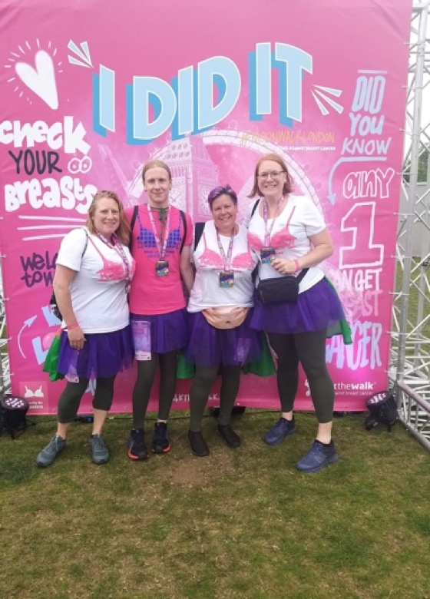

Thank you
I never dreamed I would walk around the streets of London in a bra and tutu for 10 hours but 26.2 miles, nearly 76,500 steps and 2 very sore feet later…. I DID IT!!
This was the toughest challenge I have ever done. I totally underestimated how difficult it was going to be. I have aches, pains and blisters galore but what an insane, unforgettable experience.
A massive thank you to everyone who has donated and supported me for such a wonderful cause. All money raised will go towards finding a cure for breast cancer. 👣

PARISH COUNCIL NEWS

LAST PARISH COUNCIL MEETING
The Annual Parish Meeting (where villagers are encouraged to speak about any issues they feel need addressing in the village) was held on 9 May. Questions were raised regarding planning issues, and the maintenance of the village sign, which the Parish Council agreed to investigate. This was followed by the Parish Council AGM, where Gilly Brown was re-elected as Chair and Davina Ransom as Vice Chair. We are sad to report that Claire Beavis has had to resign from the Parish Council due to work commitments. This has resulted in a vacancy, which has been advertised on social media and the village noticeboards. Anyone wishing to step forward to join the Parish Council should apply to the Returning Officer at Thanet District Council, Cecil Street, Margate, CT9 1XZ.

THE QUEEN’S PLATINUM JUBILEE
The Jubilee celebrations organised by the Jubilee Team (Del, Pete, Heather and Rachel) are well in hand and we wish everyone a fun weekend with the activities.
The Parish Council’s involvement with the Jubilee is via the Queen’s Green Canopy project, a national tree planting scheme. We will be inviting village groups and organisations to plant a tree in the village (probably at the Recreation Ground) and would also welcome applications from individuals who may wish to plant a commemorative tree. Up to £300 has been allocated from Parish Council funds to help with costs, if needed. All trees will need to be planted by the group/individual concerned and watered and looked after by them during the early years.
As June is not a good time for trees to be planted, we will be inviting people to plant them in the autumn to give them the best chance of survival. Invitations will be sent out within the next couple of months.
Any individual wishing to take part in the tree planting scheme should contact Sara Archer, the Clerk.

PLANNING
There is no news as yet on the outcome of the Heyhill appeal.
FH/TH/22/0311 - Monkton Loft, Monkton Street, Monkton - PERMISSION GRANTED for the erection of a single storey side extension and covered walkway.

NEXT MEETING
7.00 MONDAY 4 JULY
IN THE VILLAGE HALL

Contact the Parish Council via Sara Archer – clerk@monktonparish.co.uk – 01843 821989 or visit our website https/www.monktonparish.co.uk
CHURCH NEWS

The Parish Church of St. Mary Magdalene, Monkton
Part of the Wantsum Benefice with Minster, St. Nicholas-at-Wade with Sarre, & Chislet. (Together with All Saints, Birchington, Minnis Bay, Acol & St. Saviour’s, Westgate we form the Seamarsh Group of Parishes).

Vicar of the Benefice | Vacant
Benefice Administrator | Mr Matthew Hergest | 823347  www.wantsumchurches.org
Licensed Lay Minister | Mrs Sally Willins | 822428
Churchwarden (Monkton) | Mr David Mairs | 07960417493
Retired Priest (assisting) | Canon Peter Gausden | 825374
Lay Minister Emeritus | Mrs Diana Davies | 823817  www.wantsumchurches.org

To arrange a Baptism, Wedding or Funeral, please contact the Parish Administrator, Mr Matthew Hergest (see above).

If you wish to talk to someone, need support or would welcome prayer please contact: Mrs Sally Willins Telephone: 822428

Sunday Bible Readings in June

5th Pentecost/Whit Sunday Acts 2, 1-21; John 14, 8-17

12th Trinity Sunday Rom. 5, 1-5; John 16, 12 - 15 .

19th Trinity 1 Gal. 3, 23 – end; Luke 8, 26-39

26th Trinity 2 Gal. 5,1, 13-25; Luke 9, 51-end

H.M. Queen Elizabeth II Platinum Jubilee

As part of the Village Jubilee Celebrations in June, all are invited to a
special
Service of Thanksgiving at St Mary Magdalene’s Church, Monkton

on Friday, 3rd June at 3 pm

We look forward to welcoming our Civic Representatives – the Vice Chairman and Members of Monkton Parish Council

The Service will be followed by a Tea for all in the Church.
CHURCH NEWS - continued

Wantsum Benefice Services – JUNE 2022

 | Monkton | Minster | St Nicholas | Chislet
Fri 3 June  Jubilee Holiday | 15.00 Jubilee Service of Thanksgiving
Sun 5 June  Pentecost/Whit Sunday  Jubilee Weekend | 9.30 Holy Communion | 10.30 Holy Communion | 10.30 Village Worship
Weds 8 June |  | 10.30  Morning Prayer
Sun 12 June  Trinity Sunday |  | 10.30 Morning Praise | 10.30 Holy Communion | 9.30 Holy Communion
Sun 19 June  Trinity 1 | 9.30 Holy Communion | 10.30 Holy Communion | 10.30 Morning Light
Weds 22 June |  | 10.30 Holy Communion
Sun 26 June Trinity 2 |  | 10.30 Morning Praise | 10.30 Holy Communion | 9.30 Holy Communion
Sunday 3 July Trinity 3 | 9.30 Holy Communion | 10.30 Holy Communion | 10.30 Village Worship

Please check Village notice boards and/or the Benefice web site for any developments and changes.

St. Mary Magdalene Church – an Apology!

As Monkton looks forward this month to welcoming people for the Jubilee Celebrations and the Open Gardens Weekend, we are uncomfortably aware of the need to constantly remind visitors of the uneven areas of wooden floor in the church.

The major re ordering of the West end of the church, providing a much needed kitchen area, toilet facilities and new flooring, was completed in the Summer of 2019. Within a matter of weeks, the new woodwork had begun to move and distort.
Needless to say, we have been working hard towards getting this situation rectified but these things take time and, unfortunately, nothing will have been done before the two big events in June are upon us.

Fortunately, the church remains in regular use and we are doing our best to keep it as user-friendly as possible. We look forward to welcoming you during this festive month of June!
VIEWPOINT
June 2022
This month will see gatherings and events across the Nation as we celebrate our Queen’s Platinum Jubilee and the longest reign in British History.
In addition to offering our congratulations to Her Majesty the Queen, I believe this is also an occasion to remind ourselves of just how fortunate we are in these Islands to have such a stable system of parliamentary government and a constitutional monarchy. It is a system which has evolved and developed over nearly a 1000 years in relative calm, in stark contrast to the bloody revolution which has marked political change in so many nations of the world. Slowly, and in the main, quietly, the age old balance of power between the monarch and parliament has changed and evolved.
Today, technically speaking, the Queen still holds the supreme power of the State. She alone can appoint and dismiss ministers; she alone can open and dissolve Parliament. No Bill can become law until it has received the Royal assent. But, things have evolved in such a way as to render the monarch completely unable to exercise a personal choice in such matters. She is constitutionally bound to follow the advice of the government. Some might say this is a bit daft, but I think it’s rather clever!
A wiser head than mine has said that the strength of our system of government lies not in the power it gives to the sovereign, but in the power it denies to others. It keeps the politicians in their place! The person who holds real power in the country is, of course, the Prime Minister, but note his title – ‘First Servant.’ Originally that meant servant to the monarch but now I think we should also take it to mean - first servant to the people who the monarch so loyally represents.
Today, by a strange paradox of history, our present Queen, whose royal ancestors held power over the people, now represents the power of the people. When she opens Parliament and speaks the words: “My Government….”, I believe she is speaking no longer as the absolute monarch, but as the voice of the electors, a veritable “Britannia,” reminding the Government, and indeed, Parliament who its masters really are!
While the Queen necessarily takes no active part in the political processes, she has the right to be consulted and she listens, advises, suggests and questions. She is well travelled, well read and well informed and prime ministers of all parties have testified gratefully to her wisdom. Over seventy years now, our Queen has given unstinting and constant service to both Britain and the Commonwealth. Inevitably, at 96, she has had to cut back on her activities but her life is still governed by a demanding diary whilst the despatch boxes follow her everywhere.
In her broadcast messages, the Queen speaks frequently of her

VIEWPOINT - continued

personal faith in God and I believe it is this which sustains her in her tremendous responsibilities. She is also Supreme Governor of the Church of England and although this role too is “non-executive” it seems that in some strange way she is able to point us towards that spiritual dimension of life which we often shy away from but know we ought to explore.
On this great occasion of the Platinum Jubilee we can give thanks for that indefinable something which holds us together as a nation, especially in times of crisis. We cannot define it but I believe it is very much encapsulated in the person of Her Majesty, Queen Elizabeth II.
Peter Gausden

Minster Open Gardens
Minster are holding their Open Gardens on the weekend of 18th & 19th June. 10am to 5pm. Tickets and refreshments available in the Old Schools and gardens. Admission £5 (accompanied Under 14’s free). Proceeds in aid of St. Mary’s Church building.

Minster Show – Saturday 23rd July 2022
Minster Show - Saturday 23rd July 2022 - We're Back !!
Residents of Monkton, St Nicholas, Sarre, Acol, Manston and Cliffsend are reminded that they are all eligible to enter items into the various sections in the Show Tent for this event.
Show Schedules, with entry forms, will be available from the beginning of May at various businesses in Minster, so don't forget to get yours and get growing, cooking, crafting and colouring!
We'd love to see more entries from outside of the village, make this your year!!
To those who would just like to come along on the day, the show is held on the Recreation Ground in St Mildreds Road and gates open at 1pm, Show starts at 2pm, cost is £3pp, under 5s free.
Lots to do and see, a great afternoon's entertainment for all. Prior to opening, get along to the centre of the village to see the floats and carnival courts parade through Minster, procession starts at 1.40pm from Freemans Road, travels along Monkton Road, High St, St Mildreds Road and into the showground.
Ray Owen
THE WOMBLES OF MONKTON

What does a teapot, a can of soup and a pair of pants all have in common? They were all found by the Wombles around Monkton, aka Monkton’s litter pickers who work together to make our community a better place. These oddities may sound funny to you, but the reality that these items have been carelessly discarded is no laughing matter. There are currently 8 volunteer litter-pickers who regularly go out around the village, who value the cleanliness of Monkton so highly and enjoy doing their part for the environment. Just one person making sure to dispose of their litter properly can make such an impact on the world around us and help to keep our village and protect the local wildlife. I had the pleasure of speaking to two of the volunteers helping to keep our community tidy, Lynn and Robert, who have been litter picking for around 4 years now. Something they felt was especially troubling was at the end of Millers Lane, where two, large bags of DIY waste which had been fly-tipped, were spewing out into the road across the whole pavement. They also spoke of litter picking near St. Nicholas’ where they saw a field practically covered in empty vodka and gin bottles! A secret menace also plaguing our streets are cigarette butts! They may seem so insignificant due to their size but they do in fact not break down, so if you’ve had a smoke, please put your butts in a bin! If you now feel that you would like to get involved, why not contact Davina Ransom, one of the Parish Council members helping to organise the tidy-up effort around the village. if you would like to get in contact with Davina, you can drop her an email: davina.ransom@cransom.plus.com
Max Hunt

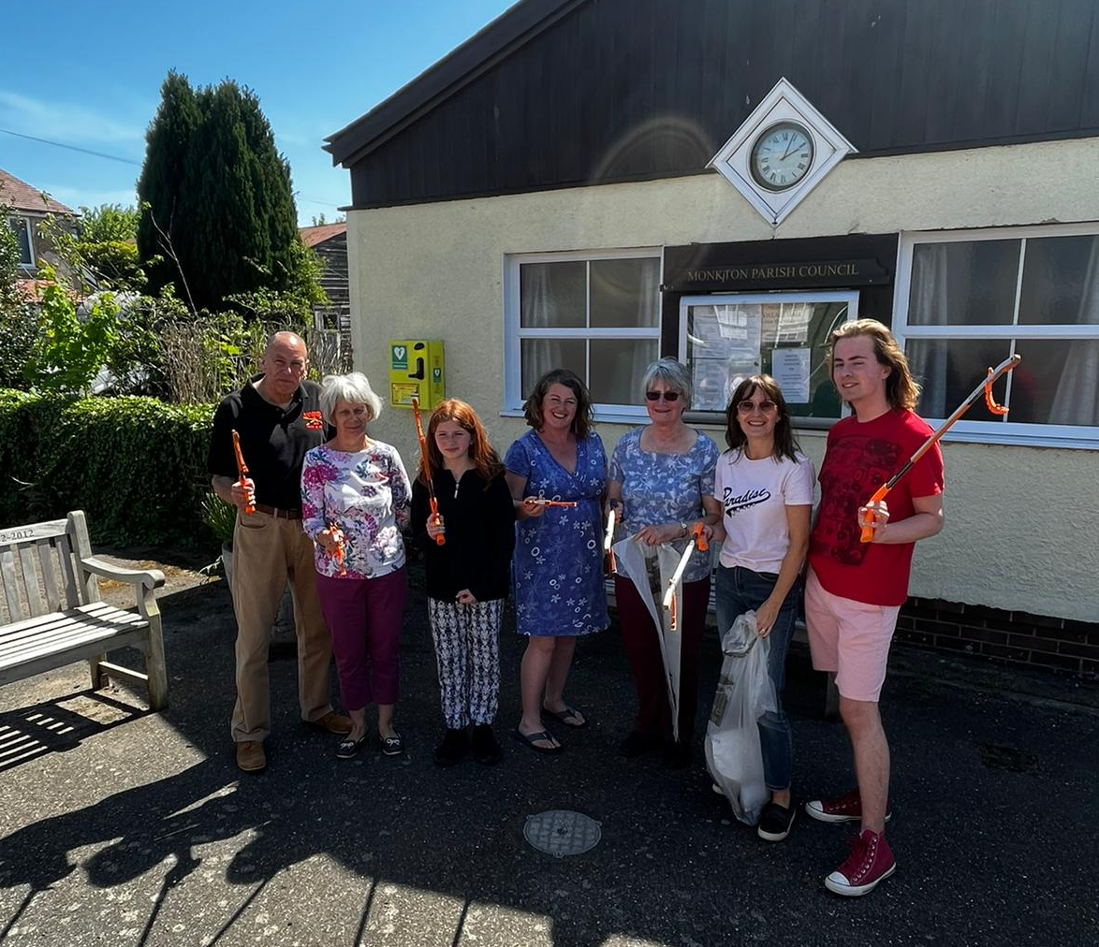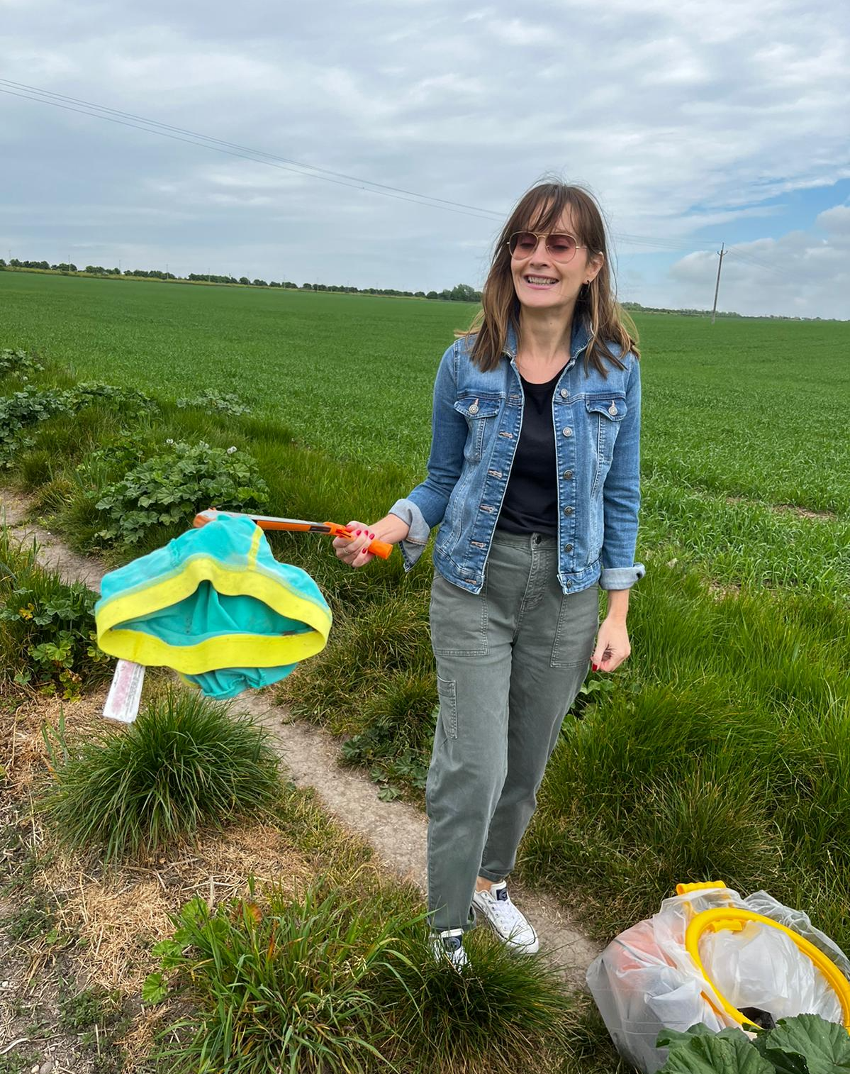


MINSTER SURGERY PATIENT LIAISON GROUP

UPDATE REMINDER - COVID-19 VACCINATION CENTRE
The Vaccination Centre is located adjacent to Wickes Building Supplies and Curry's Electrical Store. It is known as Thanet Broadstairs Local Vaccination Service (LVS). There is plenty of car parking on site and it is on various bus routes. Please note change of opening times – now open every Tuesday & Thursday from 2pm to 6.30pm, every Saturday from 8am to 2pm. Drop in, no need for an appointment.
Please do not get complacent. Cases in Thanet are still worryingly high, especially throughout schools and there is no shortage of vaccines, so if you are not fully jabbed or even double jabbed, PLEASE DON’T DELAY GET YOURS TODAY!

“FACE TO FACE” Appointments
Patients will continue to receive a telephone consultation from a Doctor before being offered an appointment with the relevant healthcare professional. The number of patients who have a “face to face” is now published on our Minster surgery Facebook Page.
It is still mandatory to “WEAR FACE MASKS” when attending the Surgery, Vaccination Clinic or any NHS facility. THANK YOU.

NATIONAL DIABETES PREVENTION PROGRAMME
Search www.preventing-diabetes.co.uk where you can register to join and get involved in the programme and find useful information on how to prevent and control Type 2 Diabetes.

MINSTER SURGERY PHARMACY
Please note that our Pharmacy will be closed on Friday 1st July for refurbishment and will only be open for collections from outside the building.

CONTACT YOUR LOCAL PHARMACY
Don't forget you can get advice, help and support for most minor ailments including travel advice.

SURGERY CLOSURE DAYS
Jubilee Bank Holiday weekend:
- Thursday 2nd June - closed all day
- Friday 3rd June - closed all day

If you need to see a Doctor during these times
Please Call 111 for NON-URGENT confidential help and advice for you and your family.
For COVID-19 help and advice - Call 119
For URGENT/LIFE threatening Cases Call 999 as normal

REPEAT PRESCRIPTIONS
Please ensure you have sufficient medication to last throughout the Bank holiday period, submit request at least 3 working days beforehand to allow processing time at surgery and your local chemist. Requests submitted prematurely will be held until the due date unless a specific reason is given.

PATIENT LIAISON GROUP MEETING
Please don’t forget we are always here for you and you can contact us anytime, by phone or email as shown below.
Our next meeting will be held on Monday 6th June. If you have any questions on any of the above or concerns and suggestions you would like raised at our meeting, please contact: Ken Self on 821200 or Jeanne Lawrence on 82104 or email kenself@me.com

VILLAGE GROUPS

MONKTON GARDEN GROUP

Last month’s meeting went well. We had a general chat about how the club was going and received a few suggestions regarding future speakers for the months of July and October.
I followed these up and am delighted to say we have a full program until December.
For the next 3 months the following have now been booked:
- 13th June - BBC Kent Garden presenter Andy Garland will be speaking about the NGS (National Garden Scheme).
- 11th July - Head Gardener at Walmer Castle, Philip Oostenbrink will talk about Walmer Castle Gardens.
- 8th August - Radio Kent Garden Presenter Jean Griffin “Tales from the Potting Shed”.
Please come along and support your club. We meet in Monkton Village Hall at 1 pm.
We have tea and coffee plus a raffle. All welcome.
Visit or join our Facebook page (Monkton Garden Club)
Sue Northrop 07759390223

MONKTON BELL TOWER

Many residents may have realised that ringing has resumed on a regular basis in Monkton. We have also had a few visitors returning to ring our bells. On Saturday 14th May, Monkton hosted a striking competition. 7 teams from the local area took turns to demonstrate their skill at ringing a pattern of 240 changes. They were judged on the speed of ringing, the spacing between the bells and the method they used. A team from St Stephens in Canterbury ultimately claiming the victory. Visitors were treated to excellent refreshments and a short church service lead by our Canon Gausden.

It is hoped that the Queens Platinum Jubilee will be marked by the ringing of a full peal on the afternoon of Sunday 4th June. This requires the 6 ringers to ring all the possible combination of changes on 6 bells and takes approximately 3 ¾ hours! If anyone should make a mistake at any point it doesn’t count as a peal. Monkton is the only tower in Kent that has never had a successful attempt recorded in modern times as far as we know so this should be a fitting tribute to our longest reigning Monarch.

If all this has inspired you, we have resumed the teaching of new recruits. We are a friendly bunch and welcome anybody from Secondary age upwards with no upper age limit as long as you can manage the ladder and raise your hands over your head. Regular practice night is Friday at 7pm and we ring normally for one Service a month as well as many special occasions. For more information contact Tower Captain Rachel on 822338. Rachel Horsburgh

RESIDENTS ASSOCIATION

Thank you to everyone that attended the AGM in May. It was an open meeting and we hoped to attract more residents to join us. Welcome to our one new member! If you haven’t yet paid your annual subscription fee, please drop it into Beth or Gilly’s house asap. We started the association in 2015. One of our main objectives is ‘to work to maintain the character of Monkton Village as a distinctive rural village’. If you would like to join our group or find out further information, please contact me on 821486. Beth Johnson

RECYCLING AND WASTE COLLECTIONS FOR JUNE

I have checked with TDC and they informed me that they are going to carry out as many collections as possible during the platinum jubilee bank holidays, so hopefully we won’t be affected. Make sure that your bins are out by 7.00am to ensure yours is collected.

Friday 3rd June – Black bin (general waste)
Monday 6th June – Green bin (garden waste)
Friday 10th June – Blue recycling bin and red bag for paper
Friday 17th June – Black bin (general waste)
Monday 20th June – Green bin (garden waste)
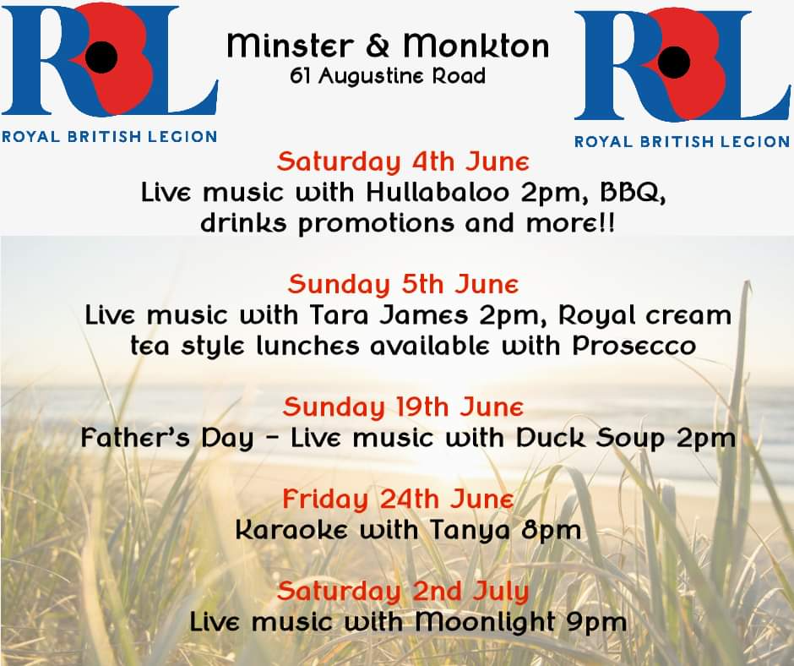
Friday 24th June – Blue recycling bin and red bag for paper
MONKTON NATURE RESERVE

RESERVE AND NATURE TRAILS - ENTRANCE FEE APPLIES
NATURAL HISTORY MUSEUM
SECONDHAND BOOKSHOP - DONATIONS WELCOME
THE CABIN CAFÉ
NATURE SHED PROJECT

Open Saturday, Sunday, Tuesday & Thursday 10.30-3.30pm
Web site: https://monkton-reserve.org/
Tel: 01843 822666 Email: contact@monkton-reserve.org

EVENTS IN JUNE

Sunday 19th – Bushcraft Sessions
10-noon (ages 5-8 years)
12.30-2.30pm (ages 9-12 years)
Booking and charges apply – email education@monkton-reserve.org

Friday 24th – Twilight Book Evening (6-9pm)

PLEASE NOTE
THE RESERVE WILL BE CLOSED ON THURSDAY 2ND JUNE, THE JUBILEE BANK HOLIDAY – OUR VOLUNTEERS NEED A BREAK TOO!

Registered Charity – Thanet Countryside Trust 285972

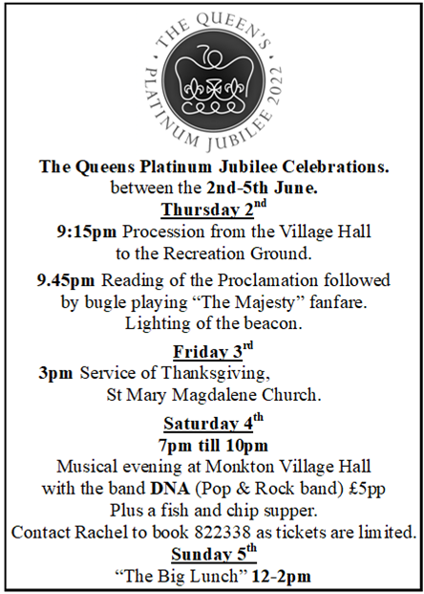

Lemon Swiss Roll and Amaretti Trifle

Platinum Jubilee Pudding – photo on cover
For this recipe you will need 2 Swiss roll tins, measuring approximately 24cmx34cm/9½inx13½in and a trifle dish with capacity of approximately 3.5 litres/6 pints. It serves 20, however, you could always halve the recipe. I’ve just made the ‘cheats version’, but if you want to make everything from scratch, you can easily find the full recipe online. (Front photo and recipe sourced from bbc.co.uk).

Ingredients

For the Swiss rolls
- 4 large free-range eggs
- 100g/3½oz caster sugar, plus extra for dusting
- 100g/3½oz self-raising flour, sieved
- butter, for greasing

Lemon curd - 300g/10½oz ready-made lemon curd.

St Clement’s jelly - use 1 packet of lemon-flavoured jelly to make 568ml/1 pint

Custard - use 500ml/18fl oz ready-made custard

Amaretti biscuits - 100g/3½oz ready-made amaretti biscuits.
Double Cream - 600ml/20fl oz

For the chunky mandarin coulis
- 4x tins mandarins, around 300g each
- 45g/1¾oz caster sugar
- 16g/½oz arrowroot (2 sachets)
- ½ lemon, juice only

For the jewelled chocolate bark
- 50g/1¾oz mixed peel
- 1 tbsp caster sugar (optional)
- 200g/7oz white chocolate, broken into pieces

Method
- To make the Swiss rolls, preheat the oven to 180C/160C Fan/Gas 4. Grease and line the 2 Swiss roll tins with baking paper. In a large bowl, beat the egg and sugar together with an electric hand whisk for approximately 5 minutes or until light and pale. Using a metal spoon, gently fold in the flour. Divide between the two tins and bake for 10–12 minutes or until the sponges are lightly golden and cooked through. Sprinkle some extra caster sugar on two sheets of baking paper then turn the sponges out onto the sugared paper. Peel off the paper from the underside and, while still warm, roll them both up from the short end into a tight spiral using the paper to help. Leave to cool.
- To make the chunky mandarin coulis, strain two tins of mandarins. Discard the juice and put the fruit into a saucepan with the sugar and heat gently until broken down. Remove from the heat. In a small bowl, slake the arrowroot with 2 tablespoons cold water then add to the warm mandarins. Add the lemon juice and mix well before pouring into a large bowl. Strain the remaining two tins of mandarins and add the fruit to the bowl then leave to cool completely.
- To make the jewelled chocolate bark, if the peel feels wet or sticky, roll in the caster sugar to absorb any moisture. Melt the white chocolate in a bowl sitting over a saucepan of gently simmering water. Pour the white chocolate onto a baking tray lined with baking paper and scatter over the mixed peel. Leave to set then break into shards.
- To assemble, unroll the cooled Swiss rolls and spread with the lemon curd. Roll back up again and slice one into 2.5cm/1in slices and place upright around the bottom edge of the trifle dish so the swirl is visible. Slice the other Swiss roll into thicker pieces and use these to fill the bottom of the dish, ensuring the top is roughly the same level as the slices that line the edge. Use off-cuts of sponge to fill any gaps.
- Pour the St Clement’s jelly over the Swiss roll layer and set aside in the fridge to completely set. This will take approximately 3 hours. Once set, pour over the custard then arrange a single layer of amaretti biscuits, keeping a few back for the top. Pour over the mandarin coulis. In a large bowl, whip the double cream until soft peaks form then spoon this over the coulis. Crumble over the reserved amaretti biscuits and decorate with the chocolate bark shards.

ADVERTISING SECTION
YEARLY ADVERTISING RATES

As the printing of the magazine is no longer in-house, we have had to increase the rates to those below:

Full page £90 Half page £45
Quarter page £25

All fees payable in advance – please make cheques payable to St. Mary Magdalene Church.
TO PLACE AN ADVERT CONTACT
monktonnews@gmail.com



Procanoil

Quality hemp, and MCT coconut derived CBD Oils.
We are a small family run business based in the South East of England who pride ourselves on offering quality products at very affordable prices.
We are a new brand that you can trust when purchasing from us. Procanoil CBD infused oils are quality food supplements that can help enhance your daily life.
See Website for further detail. www.procanoil.co.uk
Or contact info@procanoil.co.uk for advice.
Discounted costs to Monkton residents, ask for detail using info@procanoil.co.uk or orders@procanoil.co.uk


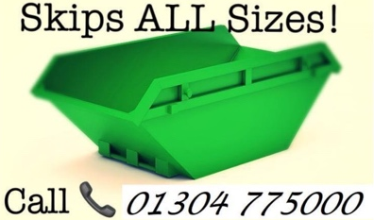
SLM WASTE MANAGEMENT LTD.
THE STARTING POINT FOR ALL YOUR WASTE SOLUTIONS
KENT BASED AND ENTIRE UK COVER
ALL TYPES OF WASTE DISPOSAL SERVICE
- SKIPS AND RORO
- HAZARDOUS WASTE
- CHEMICALS, INKS

- CLINICAL WASTE
- PLASTICS
- CARDBOARD
- GENERAL WASTE AND RECYCLING

LET US DEAL WITH ANY TYPE OF WASTE OR HELP YOU WITH
FACILITIES MANAGEMENT
CONTACT: -
PHONE: 01304 775000 or MOB 07710503581
Email lucy@slm-waste.com

Support Network Services Limited
Business and domestic computer support, consultation and troubleshooting
Very experienced network engineers
Microsoft, Novell and Citrix qualified
Also Apple Mac knowledge
Variety of skills including installation, and repair of pcs, servers, printers wired and wireless networking and broadband
VIRUS AND SPYWARE REMOVAL
FRIENDLY LOCAL COMPANY, MONKTON
CONTACT 01843 822430
EMAIL info@supportnetwork.co.uk


All roofing works undertaken
Monkton village based
Re-Roofs - Flat, Tiled or Slate.
Roof Repairs Flat, Tiled or Slate
Repairs and Re-bedding of Hips, Valleys, Ridges and Verges
Vertical Cladding - Weatherboards, Cedar Shingles and Kent Peg Tiles
Leadwork & Chimney Repairs/Chimney maintenance
UPVC Fascias, Soffits & Guttering
Felt Support Trays/Felt Repairs
Velux Window Installation & Repairs
Roof space Ventilation and insulation
Bird Deterrents - Pigeon/Seagull Netting/Bird Spikes
CONTACT US
PHONE: 01843 838447 www.grasby-roofing.co.uk
Email: info@grasby-roofing.co.uk
The Pierson Cake Company
MONKTON, KENT
Cakes for all occasions
01843 319215
mobile 07530 857163
email Francesca_drake@hotmail.com
find me on FACEBOOK: -
The Pierson Cake Company

ANDREW PEALLING
PLUMBING CONTRACTOR

MONKTON BASED
EXPERIENCED AND RELIABLE
For a free quotation
Contact
OFFICE 01843 822244
MOBILE: 07789 242467

A
LERT PLUMBING AND HEATING

Plumbing
Boiler service and repairs
All plumbing and heating work undertaken – 24-hour emergency call out available
01843 265009
www.alertplumbing.co.uk
email : noel@alertplumbing.co.uk

- Main
- Potterton
- Baxi
- Alpha
- Vaillant
- Worcester
- Ariston and Bosch group

K.S.BRICKWORK
36 Hunting Gate, Birchington
For free quote and advice on
- Home extensions
- Garages
- Garden walls and patios
Call Keith: 01843 841488
Or mobile: 07745 401996



NP
ELECTRICALS
BS7671 QUALIFIED ELECTRICAL ENGINEER
ELECSA – part of the ECA GROUP
PART B REGISTRATION NO. EPP2390
All electrical work undertaken
*free quotations *Competitive prices *Quality workmanship
*Fully guaranteed
CALL NIC MORLING
07714 580 978
Serving the villages since 2005
www.npelectricals.co.uk

RACHEL’S D.I.Y. SERVICE
PAINTING, DECORATING, TILING
FLAT PACK FURNITURE
LADY DECORATOR
Free quotes and no job too small
Contact: 01843 822338
Email:- rachel@rachelsdiy.co.uk

GARY MOSS
CHIMNEY SWEEP
CONTACT 01304 271053
MOBILE
07928 230007
ICS registered member

R.B.W.
KENT’S WATER FEATURE AND POND BUILDING EXPERTS
Garden / pond design/ building and refurbishments/ pond cleaning/ maintenance/ maintenance contracts
Child safe pond covers
Filtration specialists
Patios – decking – fencing – brickwork – arbours
Tel: - 07563212858
Free estimates and consultations

www.ReflectionByWater.com
Email: andrewlongrbw@hotmail.com

SJG

HOME IMPROVEMENTS
- Refurbishments
- General building
- Domestic and commercial
- Kitchens and bathrooms
- Painting and decorating
- Carpentry sash windows
- Laminate and wood flooring
- Tiling, dry lining, coving
For a free estimate
CALL
01843 822191
MOBILE: 07966 495 804

sjghomeimprovements@sky.com
www. sjghomeimprovements.com





COLE’S GARDENING SERVICES
Friendly and reliable lady gardener
Lawn cutting. pruning, tidying , hedge cutting
NO JOB TOO SMALL
CONTACT
07916740078 - ask for Carol
OR EMAIL
c.colegardening@gmail.com




