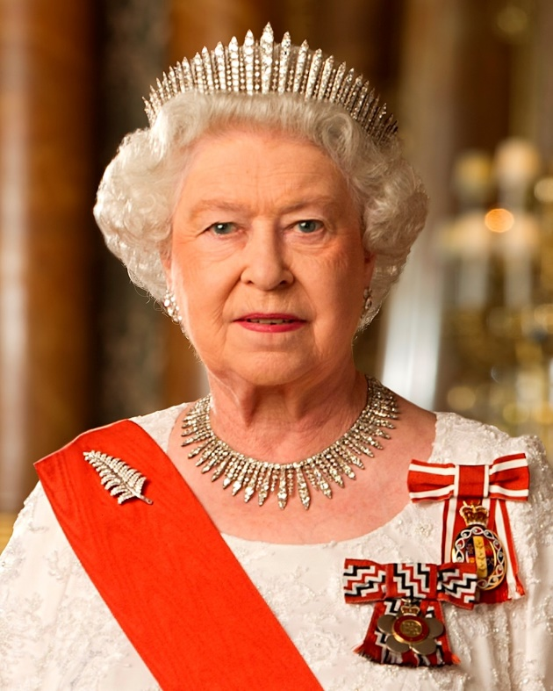
HER MAJESTY QUEEN ELIZABETH II
21ST APRIL 1926 – 8TH SEPTEMBER 2022

FOLLOWING THE SAD NEWS OF THE DEATH OF HER MAJESTY QUEEN ELIZABETH II THERE WILL BE A BOOK OF CONDOLENCE LEFT AT THE CHURCH

FLORAL TRIBUTES MAY BE LAID AT THE VILLAGE HALL AND SHOULD BE LEFT UNWRAPPED OR WRAPPED IN COMPOSTABLE MATERIAL

THE READING OF THE PROCLAMATION WILL BE HELD AT THE VILLAGE HALL ON MONDAY 12TH SEPTEMBER 2022 AT 3PM

THE QUEEN HAS GIVEN A LIFETIME OF SERVICE TO THIS COUNTRY AND WILL BE REMEMBERED WITH AFFECTION AND GRATITUDE

MONKTON PARISH COUNCIL

