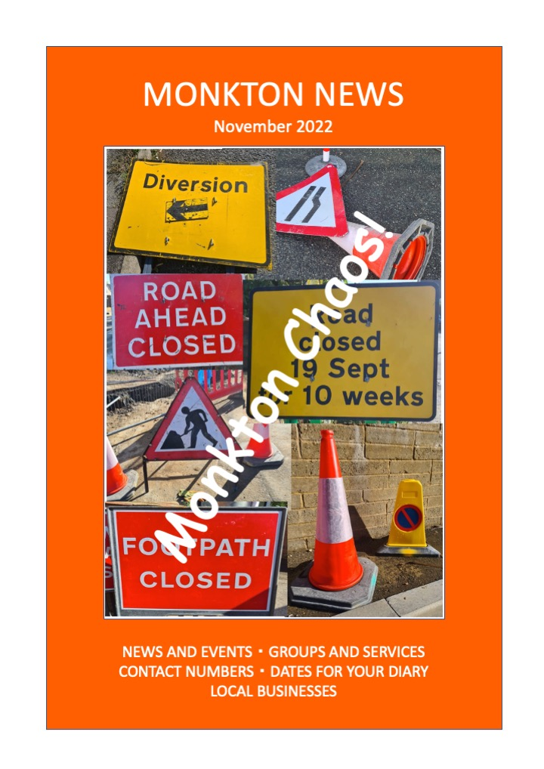


WHAT’S IN YOUR NOVEMBER 2022 MONKTON NEWS
Page
1 | Contents / Who Does What / Thanet Food Link
2 | Useful numbers and contacts
3 | Village hall diary / Editorial / Monkton Food Link
4 | Father Christmas Information Poster
5 & 6 | Parish Council News
6 | A Breath of Fresh Air!?
7 & 8 | Church News
9 | Viewpoint from Diana Davies
10 | Wantsum Benefice ‘Always Remembered’ Poster
11 & 12 | Minster Surgery Patient Liaison Group
12 | Monkton Nature Reserve
13 | Village Groups
14 | Harvest Supper Thankyou’s / Beatlemania / Window Wonderland
15 | Do We Remember? Poem by Pete Mitchell
16 & 17 | Christmas Dinner Information, Menu and Bookings
18 | Royal British Legion Events
19 | Memories of Monkton
20 | Monkton School News
21 + | Advertising Section

WHO DOES WHAT IN MONKTON NEWS?

Editor – Gilly O’Neill
Distribution Kay & Harry Horne tel: 823849 Email: shudy@talk21.com
Articles and letters for Monkton News should be sent to:

monktonnews@thecroft.me

BY THE 19TH OF EACH MONTH.

THANET FOOD LINK

AT THESE PARTICULARLY DIFFICULT TIMES THERE ARE
FAMILIES THAT RELY ON OUR HELP AND GENEROSITY
PLEASE PLACE DONATIONS OF FOOD IN SHED
ADJACENT TO GATE
AT 153a MONKTON STREET
THANKS FOR YOUR SUPPORT
Further information from Kay or Harry Horne
823849/shudy@talk21.com
USEFUL NUMBERS AND CONTACTS

POLICE NON-EMERGENCY  101 | MINSTER DOCTORS’ SURGERY 821333. Out of hours call 111
CRIME STOPPERS  0800 555 111 | SOCIAL SERVICES  860000
PCSO Brandon Greenleaf | MINSTER LIBRARY  03000 413131  Open: Tues 09.30-13.30; Thurs 12-17.00; Fri 10.00-16.00 & Sat 09.30-13.30
DOMESTIC VIOLENCE HELP  07926 842 183  www.domesticabuseservices.org | SOUTHERN WATER to report a leak 0800820999  Supply or sewage problems  0330 303 0368  Billing 0333 200 3015
MONKTON C OF E PRIMARY SCHOOL 821394 | RSPCA  0300 1234 999
THANET DISTRICT COUNCIL – for all department information www.thanet.gov.uk  577000 | Parish clerk – Sara Archer 821989  clerk@monktonparish.co.uk  www.monkton parish.co.uk
THANET DISTRICT COUNCIL  Planning 577591 | Dog warden and noise control  577580
THANET DISTRICT COUNCIL  Recycling and fly tipping  577115 | MONKTON VILLAGE HALL BOOKINGS  821439
QEQM HOSPITAL  225544  Outpatients appointments line  01227 868686 | MINOR INJURY UNITS  Kent and Canterbury Hospital  24 hrs 01227 864244  Estuary View, Whitstable CT5 3SE  8-8 daily 01227 284301
NEAREST POST OFFICE  Minster 821291 | Opening Times: Mon-Fri 08.00-17.30 (closed for lunch 14.00-15.00) Sat 09.00-13.00

The Editors accept all advertisements, articles and notices in good faith and actively encourage the support of local traders and services. However, we cannot be held responsible for the quality of goods or services offered. The Editors reserve the right to alter, omit or hold over copy as they see fit. Views expressed herein are strictly those of their author and do not necessarily agree with those of the Editors.

MONKTON VILLAGE HALL DIARY FOR NOVEMBER

DAY | TIME | EVENT | CONTACT
Sunday | 11.00-13.00 | Ballroom and Latin American Dance | Gordon and Pauline
Monday | 09.15-10.15  13.00-15.00 (2nd Mon of each month)  19.00 | Dance exercise  Gardening Club  Dog agility and behaviour training | Maggie  Sue Northrop 07759390223  Chris Paris Brown  01227 365381
Tuesday | 19.30  19.30 (3rd Tues of each month) | Adult table tennis  WI | Gilly Brown  Penny Coleman 821539
Wednesday | 10.00-12.00  19.00-21.00 | Retired villagers’ social morning  Line Dancing | Sara Archer  821989  Theo Loyla 833643
For further information contact Pete Mitchell, 821439. If your club or activity is not in this month’s diary, please contact your organiser.

EDITORIAL

Don’t know about you, but I’m fed up with these roadworks. Bringing chaos to our village and adding on extra miles for all of us. Hey ho, someone must be benefiting….& only another 4 weeks to go!!!
On the positive side, what generous villagers we have in Monkton, contributing to the Food Link (p.3) and raising money for the Macmillan Cancer Support Charity at the Harvest Supper (p.14).
We’ve lots to look forward to with Christmas just around the corner – Father Christmas will be visiting the Village (p.4), the Christmas Dinner (p.16 & 17) and the Window Wonderland (p.14). And there’s a date to put in your diary in 2023 if you like the Beatles. See the brief notice on p.14, more details to follow early next year.
Thank you to Pete Mitchell for his poignant poem (p.15), Terry Marsh for his Monkton Memories (p.19) and Chris Marston (p.20) for the school update. As always, we look forward to receiving your contributions.

MONKTON FOOD LINK
A big THANK YOU to Monkton School and the congregation of Monkton Church for the huge amount of food donated for the Thanet Food Link during Harvest Festival. Much to the appreciation of the distributions, we delivered eight overflowing trays of much needed food.
Thank you again for your generosity during these difficult times.
Kay and Harry Horne
MONKTON VILLAGE HALL
24th December
Father Christmas & His Helpers will be in the Hall 4-6pm
To Distribute your Presents
If you wish to take part in this Event
Contact: 01843 821439 (between 10am-6pm) by the 20th December
Your Presents will be collected on
FRIDAY 23rd December 4-6pm

PRESENTS MUST BE SECURELY WRAPPED AND
MARKED WITH THE FULL NAME CLEARLY IN BOLD LETTERS AS FATHER CHRISTMAS IS QUITE ELDERLY

Light Refreshments will also be served.
For security reasons No presents will be kept in the Village Hall prior to the event

This is of course Government Regulations Permitting
This a Free Event sponsored by Friends of the Village Hall

JOIN THE HORSBURGH FAMILY AND GUESTS AFTERWARDS @ 6PM FOR ACCOMPANIED CAROLS BY THE VILLAGE TREE FOLLOWED BY FESTIVE LIGHT REFRESHMENTS
PARISH COUNCIL NEWS

New Play Area
It was a great pleasure to officially open the new Play Area in beautiful sunshine back on October 1st. The names of all the children who came along were put in a hat and a winning name drawn out. The winner had the great honour of not only cutting the ribbon but also giving their name to the Play Area. So, our new play area is now called Izabella’s Play Park!
Thank you to all the Villagers and children who turned up, and special thanks to the representatives of the Robinson Trust and our County and District Councillors, Linda Wright, Derek Crow-Brown and Reece Pugh who supported the scheme and also came along to enjoy the opening ceremony.
We are so delighted to have been able to raise full grant funding for this project – something we thought would not be possible at the outset - but thanks to a lot of work and research by Sara, our Clerk, we got there in the end. The exciting range of new equipment has been very well received by our younger villagers and their friends. We hope you will all enjoy Izabella’s Play Park for many years to come …..

The Queen’s Green Canopy Tree Planting Scheme at the Rec Ground
It has finally come round to tree planting time! Our thanks and appreciation to all the village Organisations who are supporting this scheme and planting a commemorative tree.
We have decided on the weekend of Nov 19/20th as the main planting weekend. Hopefully there will be plenty of rainfall in the build up to ease the job of digging the planting holes!
All the trees will be planted around the periphery or in the wild areas at the Rec. As they mature, they will gradually add to the biodiversity and attractiveness of the area, as well as adding to the history associated with many of the trees that have been planted at the Rec.

Free rapid lateral flow test kits
The Parish Council still have around 50 free kits for distribution in the village. These are available through Davina Ransom (tel 821446).
Do give Davina a call if you would like a kit – all villagers are welcome.
Because of limited supply, we may have to restrict kits to one per household.

Road Closure
The Monkton Street road closure has caused a lot of problems and inconvenience for villagers. We have been working on finding a solution …. Cllr Derek Crow-Brown has been on the case with KCC Highways to see if there is any possible alternative to the closure, or if the road could
PARISH COUNCIL NEWS- continued

be opened up again more quickly. Sadly, the answer to both questions is no – this is a major works scheme, and traffic lights to keep the road partially open are apparently not an option. Unfortunately we are therefore stuck with the road closure for a few more weeks.

Planning
OL/TH/22/0713 – Land Rear of 62 Monkton Street, plans have been amended from 2 x 3 bed semis to 2 x 2 bed single storey detached houses – DECISION PENDING
FH/TH/22/1214 – 130 Monkton Street – extension of existing vehicular access – PENDING
TCA/TH/22/1305 – Monkton Court – tree works – PENDING
Heyhill – still waiting for the Appeal decision

NEXT PARISH COUNCIL MEETING- THURS 3rd NOVEMBER, 7pm, Village Hall
All are very welcome to come along!

To contact the Parish Council: Sara Archer – clerk@monktonparish.co.uk
01843 821989 or visit our website https//www.monktonparish.co.uk

----------------------------------------------------------------------------------------------------------------

A BREATH OF FRESH AIR!?

Now that we are having church services of Holy Communion fortnightly rather than weekly at Monkton Parish Church, we have been thinking about how we might best use the morning slots on the Sundays in between. We’d like to do something different; something less “traditional” which helps us to think more widely!”

Could you help us, please, particularly those of you who do not attend a church? We would like to hear your questions or criticisms, and to know what you might be thinking - about God and the Church, national or local, and their relevance in these very challenging times?

We will be meeting, for about an hour, on Sunday, 27th November at 10.30 am in St Mary Magdalene Church for coffee and some talking about what you put before us.

If you are able to join us, you can be assured of a warm and grateful welcome! Alternatively I, or any church member, would be delighted to receive beforehand your questions or challenges, written or spoken, and any request for anonymity will be respected.
Peter Gausden
Tel: 825374
Email: peter.gausden374@btinternet.com
CHURCH NEWS

The Parish Church of St. Mary Magdalene, Monkton
We are part of the Wantsum Benefice which comprises the Church of England Parishes of Minster, Monkton, St. Nicholas-at-Wade with Sarre, & Chislet. (Together with All Saints, Birchington, Minnis Bay, Acol & St. Saviour’s, Westgate we form the Seamarsh Group of Parishes).

Vicar of the Benefice | Vacant
Benefice Administrator | Mrs Sheila Greenstreet | 077887 91468
Licensed Lay Minister | Mrs Sally Willins | 822428
Churchwarden (Monkton) | Mr David Mairs | 079604 17493
Retired Priest (assisting) | Canon Peter Gausden | 825374
Reader Emeritus | Mrs Diana Davies | 823017
On Line Contact: info@wantsumchurches.org www.wantsumchurches.org

To make any general enquiries, or to arrange a Baptism, Wedding or Funeral, please contact the Parish Administrator, Mrs Sheila Greenstreet (077887 91468 or info@wantsumchurches.org).

If you wish to talk to someone, need support or would welcome prayer please contact: Mrs Sally Willins Telephone: 822428

Christmas Carols at St. Mary Magdalene Church

On Tuesday, 13th December we shall be delighted to welcome children and parents of Monkton CE Primary School for their Christingle Service beginning at 6pm.

Thanks both to Covid and the problems with the church floor, the traditional Candlelight Carols with children’s Nativity play has not taken place since 2019.

This year we will certainly have a Christmas Carol Service in the church on Sunday, December 18th at 6.30pm but the extent to which we can involve the children has yet to be determined. Please note the date and watch for further details in the December “Monkton News”.

Christmas Craft and Charity Fair
The Friends of St Nicholas at Wade Church are holding a Christmas Fair at St Nicholas Church on Saturday 19th November, 10am-2pm. There will be craft, charity and cake stalls. Tea & coffee. Ploughman’s lunch available from 12-1.30pm. Free entry.

CHURCH NEWS - continued

Wantsum Benefice Services – NOVEMBER 2022

 | Monkton | Minster | St Nicholas | Chislet
Sun 6 November 3rd before Advent | 9.30 Holy Communion | 10.30 Holy Communion | 10.30 Morning Worship
Weds 9 November |  | 10.30 Holy Communion
Sun 13 November Remembrance Sunday | 10.15 Remembrance Service, concluding at War Memorial
Sun 20 November Christ the King | 9.30 Holy Communion | 10.30 Holy Communion | 9.30 Morning Light
Sun 27 November Advent Sunday | 10.30 “Talk Shop” | 10.30 Morning Worship | 10.30 Holy Communion | 9.30 Family Praise
Sun 4 December Advent 2 | 9.30 Holy Communion | 10.30 Holy Communion | 10.30 Morning Worship

Please check Village notice boards and/or the Benefice web site for any developments and changes.

Sunday Bible Readings in November/December

6 3 before Advent 2 Thess. 2, 1 - 5 & 13 - end
13 2 before Advent 2 Thess. 3, 6 – 13; Luke 21, 5 – 19
or alternatives for Remembrance Sunday.
20 Christ the King Coloss. 1, 11 – 20; Luke 23, 33 - 43
27 Advent 1. Rom. 13, 11 – end; Matt.. 24, 36 - 44
December
4 Advent 2. Rom. 15, 4 – 13; Matt. 3, 1 - 12

Remembrance Sunday – 13 November

As always, Monkton will have a Service of Remembrance beginning at 10.15 am on Sunday, November 13th. At the end of the Service in church, we shall move outside to the War Memorial for the Act of Remembrance and the Two Minutes Silence at 11 am.
We welcome members of Monkton Parish Council with their chairperson, Cllr Gilly Brown, who will lay a wreath on behalf of the Village.

VIEWPOINT

Pastoral Reflection from Diana Davies – Reader Emeritus to the Wantsum Benefice

A Time to Remember

Dear friends,
November, the month of public remembering.
We begin on the first with the great feast of All Saints when we celebrate all those who have lived and died as faithful children of God, both those recognised by the Church and honoured with their own special days, but also the host of those whose loving faithfulness is known only to God himself.
One following day, All Souls, is when we call to mind all those whom we have loved and who have died, this day is marked here with a lovely service at St Mary’s, Minster.
The fifth of November brings bonfire night, which I suspect, is more a chance to enjoy a bonfire and fireworks display than to remember the plot to blow up parliament?
On the twelfth comes Remembrance Sunday when we don our poppies to remember and give thanks, perhaps in church or by our village war memorials, for those who died in the service of our country from the First World War to the present day.
As November and the church year draw to a close with all the chaos in our national life and in worldwide affairs, it may be tempting to go from remembering the past to retreating into it and becoming stuck in it. Nostalgia for the past may have its place but only if it gives us courage to live well in the present.
I end with these well known words of hope and comfort by Minnie Louise Haskins:
I said to the man that stood at the gate of the year,
Give me a light that I may tread safely into the unknown.
Go out into the darkness and put your hand into the hand of God
That shall be to you better than a light
And safer than a known way.
With every blessing, Diana

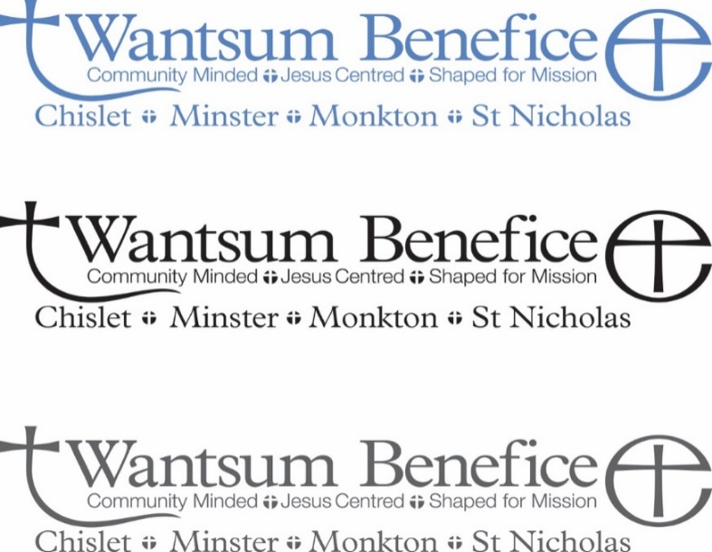

An invitation to attend
‘Always Remembered’

the service at which we remember our loved ones who have died,
and light a candle in their memory.


Minster Church
Wednesday 2nd November
(‘All Souls’ Day’)
7.30pm

This year, in the run-up to All Souls’, at Minster church there will be an alternative opportunity to remember and honour those who have died.
From Sunday 16th October, every day between 9am and 3pm, small cards will be available in the church on which to write the names of loved ones which can then be hung on the Prayer Tree.
Directions to the Prayer Tree will be placed in the church to assist those who may not be familiar with the building.
During the commemoration service on the evening of Wednesday 2nd November, there will be a period of silence during which a candle will be lit especially for all those remembered on the Prayer Tree.
The name cards will remain on the Tree until Remembrance Sunday, after which time they will be removed.

If you require any further details,
please contact Sally Willins 01843 822428 – sal.ly13@aol.co.uk

MINSTER SURGERY PATIENT LIAISON GROUP


COVID-19 BOOSTER & ANNUAL FLU VACCINATION PROGRAMME
Please Note:
- All Covid 19 and Booster vaccinations will be administered at Thanet Broadstairs Local Vaccination Service (LVS) (located adjacent to Wickes Building Supplies and Curry's Electrical Store). Opening times: 8am – 6.30pm on Tuesday, Thursday & Saturday.
- Flu Vaccinations are currently being held at the Surgery. Not had yours yet? Please contact the surgery to make an appointment asap.
- It is recommended that you wear face masks at the Vaccine Centre. It is currently optional at the Surgery.
- All patients aged 50 and over are now eligible for a Covid-19 booster which are administered at the Vaccine Centre – no appointments necessary, just walk in!

Please DO NOT get complacent - Get Boosted Now!
With covid cases rapidly increasing throughout Thanet, please don’t delay, get yours today, Especially as the new Pfizer Vaccine gives additional protection against the current Omikrom variants !

EAST KENT CANCER CAFE AND DROP IN CENTRE
A new centre is opening at the “Margate Masonic Centre” in NewCross Street on Friday 11th November where you can meet like-minded people, get a cup of tea and seek advice for you and your family.

Want To Win £100 CASH IN TIME FOR Christmas??
Or perhaps a ”Handmade Dolls Cot complete with Bedding” or one of many other prizes.
Well YOU COULD in our “GRAND CHRISTMAS RAFFLE” Tickets on sale at the surgery NOW!

SURGERY CLOSURE DAYS
Please note that the surgery will be closed on Thursday 24th November from 1pm onwards for staff training.
If you need to see a Doctor during these times:
Please Call 111 for NON URGENT confidential help and advice for you and your family.
Call 119 for COVID-19 help and advice.
Call 999 for URGENT/LIFE threatening Cases.
MINSTER SURGERY PLG - continued

PATIENT LIAISON GROUP
A full list of all Committee Members with their contact information is shown on our Notice board in the waiting room.
Please don’t forget we are always here to help and support you and you can contact us anytime, by phone or email at kenself@me.com

Our next meeting will be held on Monday 5th December and if you have any questions on any of the above or concerns and suggestions you would like raised at our meeting, please contact: Ken Self on 821200 or Jeanne Lawrence on 821049 or email kenself@me.com

MONKTON NATURE RESERVE

RESERVE AND NATURE TRAILS - ENTRANCE FEE APPLIES
NATURAL HISTORY MUSEUM
SECONDHAND BOOKSHOP - DONATIONS WELCOME
THE CABIN CAFÉ
NATURE SHED PROJECT

Open Saturday, Sunday, Tuesday & Thursday 10.30-3.30pm

Web site: https://monkton-reserve.org

Tel: 01843 822666 Email: contact@monkton-reserve.org

Books

If you have any unwanted books, please think of us!
We have a thriving second-hand book operation and are always grateful to receive book donations. Call in to the reserve during opening hours or phone/email us if you would like us to collect

Registered Charity – Thanet Countryside Trust 285972
VILLAGE GROUPS

MONKTON GARDEN GROUP

October’s speaker was Victoria Gilbert from Kent Wildlife Trust. She showed slides and advised us on what plants and flowers to grow in our own gardens to encourage bees and insects.
We had a record attendance and 4 first timers who we soon made welcome.
Our next Meeting is on Monday 14th November when Sue Harris, Head Gardener from Quex House and Garden will be our speaker.
1 pm Start at The Village Hall. £3 all welcome
Christmas raffle (as in December we have Robin White and his flower displays will be raffled).
Sue Northrop 07759390223

NEIGHBOURHOOD WATCH

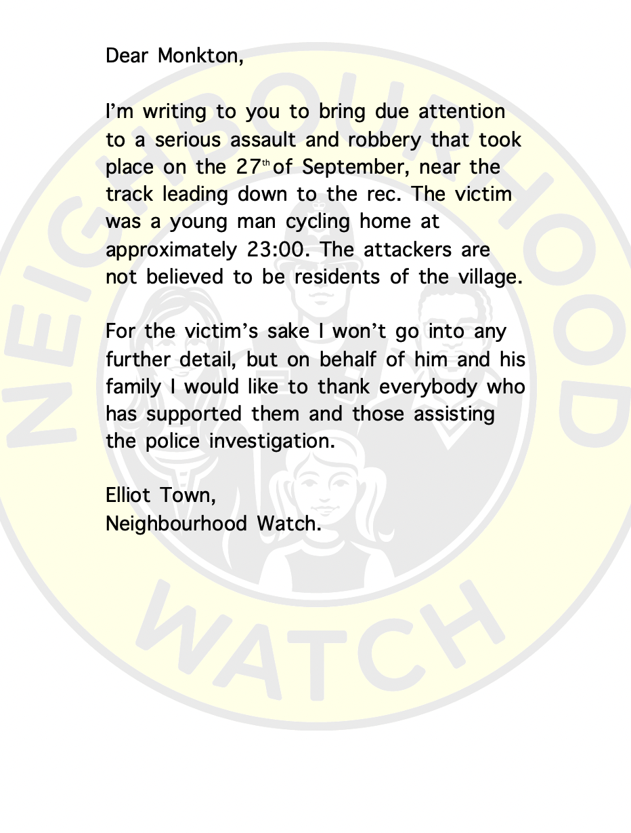
HARVEST SUPPER THANK YOU’S

Peter Mitchell reported that £182 was donated to the Macmillan Cancer Support Charity following the Harvest Supper on 1st October. Apparently, 27 people enjoyed an evening at the Village Hall, devouring a splendid Harvest fayre. Well done to the Harvest Supper Team who included Del, Heather, Pete & Terry and also to all that supported the evening. Macmillan Cancer Support Charity were very pleased with the donation and wrote a thank you letter to the Village Hall.

BEATLEMANIA – AN EVENING OF BEATLES MUSIC
Celebrate the Diamond Jubilee of Beatlemania with an evening of Beatles music played and sung by DNA in Monkton Village Hall, Saturday 18th March 2023, 7-10pm. £10, includes a hot supper. For more information see January 2023 Newsletter or ask Stuart Horsburgh.

WINDOW WONDERLAND
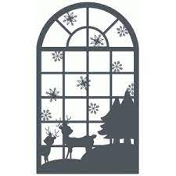

Well, I’ve 13 willing volunteers who have contacted me about our Monkton Window Wonderland, thank you! That’s brilliant, but I think we should have more windows on our map. So, get in touch with me before the 19th of November so that I can include your window on the map that will be published in December’s Monkton News and put on posters on the Village notice boards. Then everyone will be able to go to admire your window and it will bring a jolly, festive cheer to the Village. I propose that everyone who joins in the trail decorates and lights their window for the last week before Christmas. This way, no one is rushing to put up their display for the 1st of December and no one has their window appreciated just for one day (if they were given the 24th of December). Of course, you can opt to have them up & lit earlier than the 18th, but the final week would be ideal.
So, if you wish to join in the Monkton Window Wonderland, please contact me by email: gilly@thecroft.me or phone: 821232. You need to have a window that is easily visible from the road where you live and have it decorated & lit every evening from 18th – 24th December.
In decorating your window, you have artistic license - do what you like as long as there’s a Christmas theme (it doesn’t have to be religious). Idea suggestions are paper cut-outs, light displays, tissue-stained glass and snowscapes.
Looking forward to hearing from more of you.

Gilly O’Neill

Do We Remember....?

A Hundred Years have gone and more,
Since Britain entered the Greatest War,
To be over soon, the nation told,
Believed by youth but, not the old.
Young men impressed, what some did say,
And marched along to join the fray.

The war was wrong at any cost,
Whole generations I'm afraid were lost,
They understood then, the explanation,
That wrenched their lives from the nation,
Take heed young men, they may deceive,
Think hard, examine, before we grieve.

In a hundred years, ladies with wool so red,
Flanders Fields poppies, seen in their head,
For months crocheted, sewed and knitted,
Our Village then displayed and kitted,
Many Poppies red and best of all,
A six-foot Poppy man outside our Hall.

When Beacons lit, The Bells had rung,
Last Post Sounded and sad songs sung,
Times remembered and children told,
Why many young men did not grow old,
We must not forget, or was it in vain,
Then it may be repeated, once again.

In every Village, Town, and City,
So many lost that is the pity,
Each war memorial what a loss,
A little red poppy on a cross,
Box's packed put on the lid,
Do we remember, I'm sure we did

Pete Mitchell

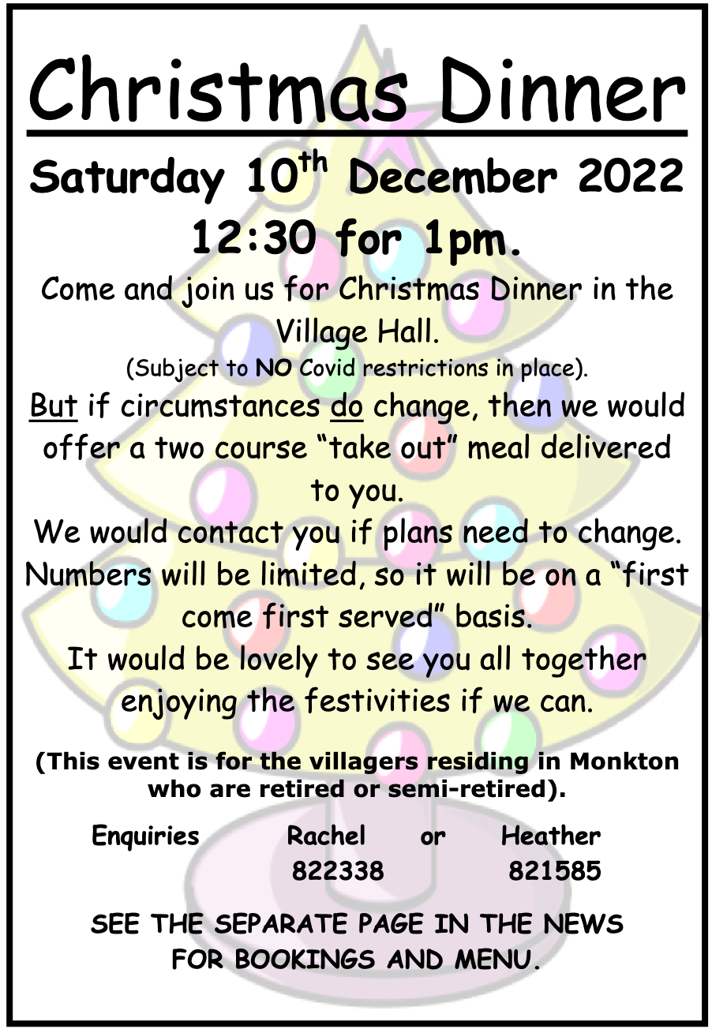
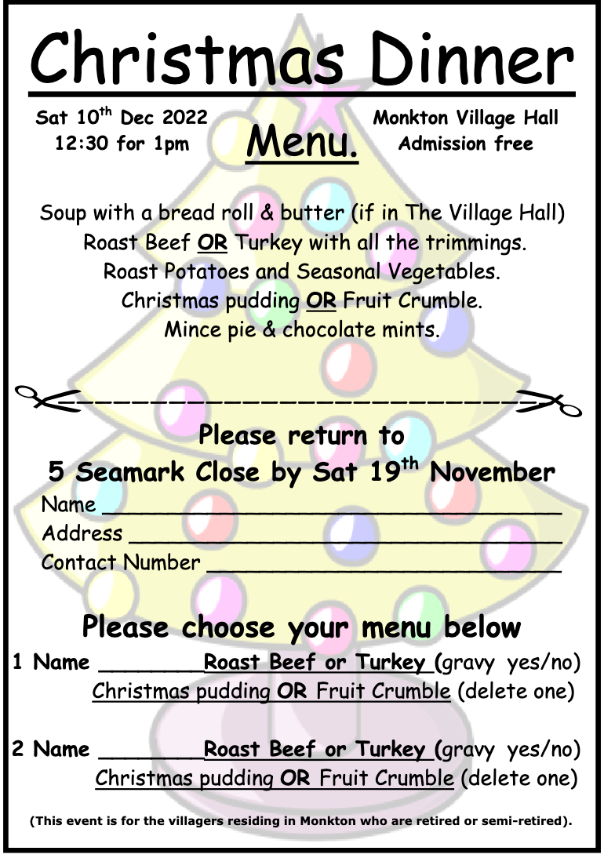

ROYAL BRITISH LEGION
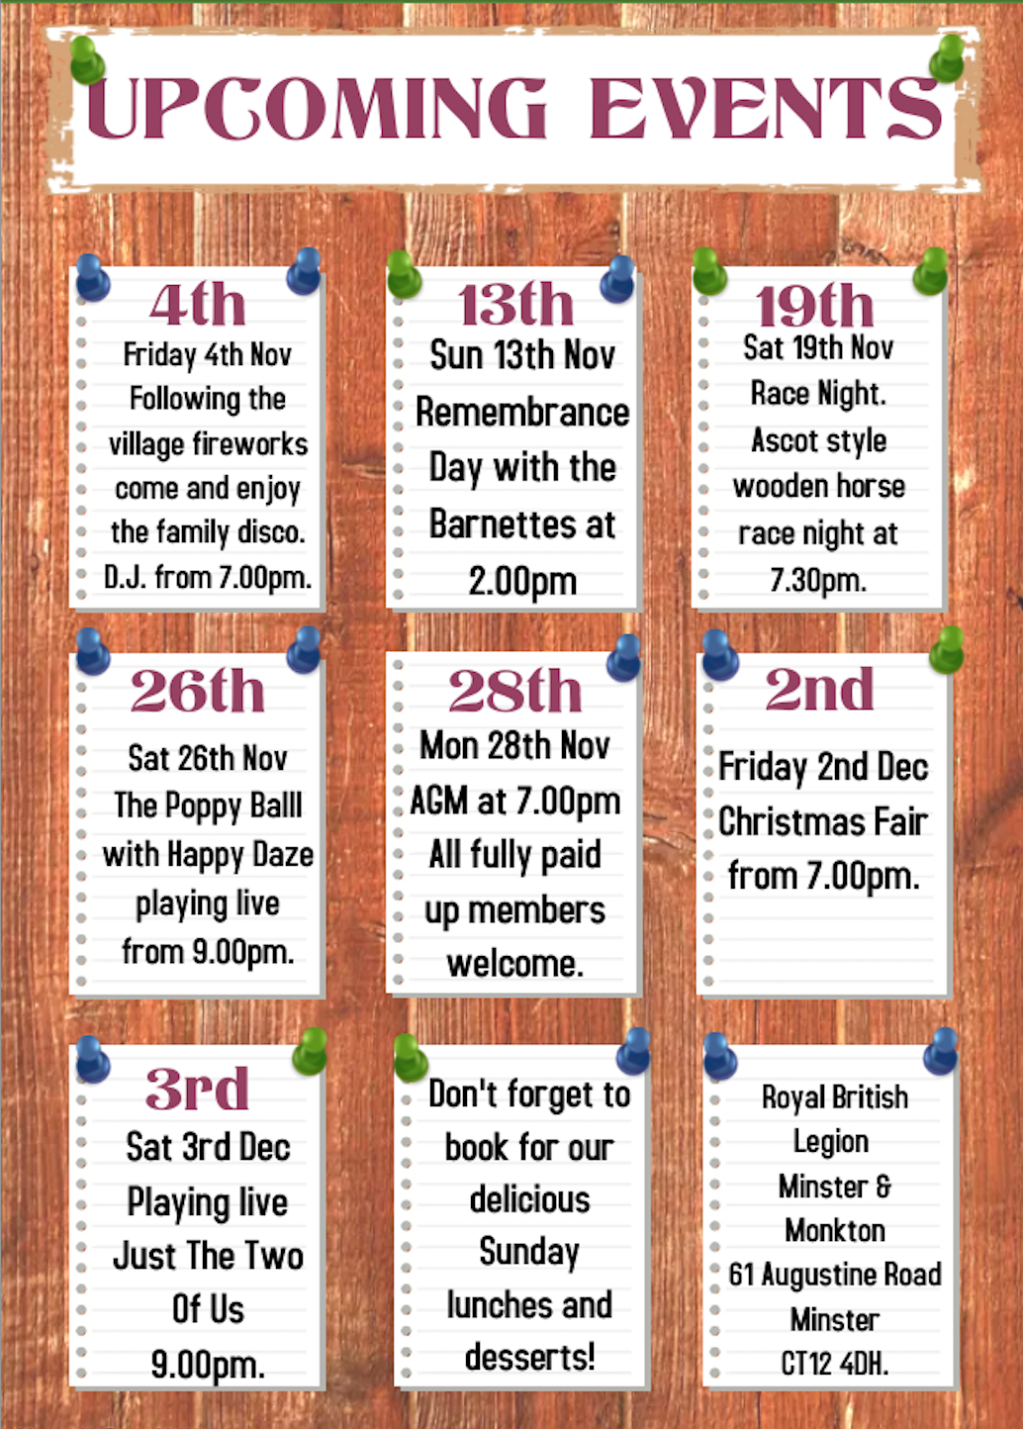

MEMORIES OF MONKTON

Dutch Elm Disease
Unless you are over 65 years old and lived in Monkton from the mid 1960's to the end of the 1970's you will not know how Dutch Elm Disease changed the scenic aspect of our village. A strain of Dutch Elm Disease first came to Great Britain in 1927 and died out by 1940. It returned in 1967, a different strain, which was both highly contagious and lethal to the English Elm. It is caused by a member of the Sac Fungi and is spread by the Elm Bark Beetles.

Elms were, by far, the most dominant large tree growing in the Parish. There were lines of them growing down each side of the Drove, along to the wood, and most of the wood (the Rookery as it was know). The road down to the sports ground and beyond. The little coppice leading into Docker Hill Farm, which was five or six times bigger than it is today, predominantly Elms. There were lines of them on the marshes near where Wendy's Cafe' is, just to name a few areas where they grew. Most of these trees were 2ft to 3ft in diameter 50ft to 70ft tall and 200 to 300 years old. By the end of the 1970's I would say that 90% of them were destroyed in a vain attempt to stop the disease from spreading.

There are now only a handful of the old Elms left and some of these do not look very healthy. If you want to find some of them there is a group of about 6, a quarter of the way down the Drove on the left-hand side. One next to the footpath just before you get to Millers Lane and one on the left, on the edge of the bank, near where the road is closed at the top of the village. There is no clear explanation as to why these few trees have not also succumbed to the disease.

There is a line of Elm trees from Millers Lane to the Church, of which we were told by Mr Michael Smith of Monkton Court Farm, that they are a different strain of Elm and would not be infected by the disease, and so far, they have not.

The roots of the diseased trees do not die which leads to 'suckers' growing from them. These trees usually grow to between 15ft and 30ft then they also fall to the disease, a good example of this along the road leading into the sports ground. Where you find these suckers growing is evidence that big trees once grew there.

It is now hard to imagine how the Parish looked at the end of the 1970's. Most of the mature trees left were Ash (now under threat from Ash Dieback) and Sycamore, which do not grow well on the marshes. A lot of the trees now growing down the Drove, along to the wood and the wood itself were planted by Mr Julian Smith after all the Elms were cut down, and in the life span of trees, are still young.
Terry Marsh
MONKTON CHURCH OF ENGLAND SCHOOL NEWS

What a busy first term we’ve had!

I’d like to thank the Monkton community first of all by supporting us unconditionally throughout the pandemic. It does seem now, that although there are still cases of covid lurking, we are coming back to some sort of normal. ‘Normal’ in a school is good – it means we have routine and enables us to create a safe and welcoming environment for the children, staff and guests to our beautiful school. Normal has enabled us to welcome visitors back into the building, to hold parent workshops with up-to-date information on our curriculum and to of course have our first ‘non-virtual’ parents evening since before the pandemic. I must admit, seeing so many friendly faces makes the job so much more enjoyable.

Now, talking about ‘friendly faces’ brings me to my next update. This term we celebrated our 150th anniversary. The school was founded way back in 1872 during the reign of Queen Victoria. Of course, the school has seen many changes since then from building refurbishments and extensions to numerous headteachers and thousands of terrific children! So, to celebrate we wanted to do something special. We invited Bishop Rose, The Bishop of Dover, to our school! Fortunately, she accepted our invitation and visited at the end of September. Bishop Rose, whilst here, had a number of duties. She led part of our daily Collective Worship, was shown around the school by some of our children and she opened our brand new Tom’s Garden – a wonderful nurture garden made possible by the Paramour Trust and the church. It was a wonderful afternoon. Bishop Rose and the other guests loved the school, the ethos, the vision and more importantly, the children. Monkton really is special – I wonder how the school is going to change over the course of the next 150 years?

As we approach half term, I’d like to thank God for keeping all the children, staff and families as safe as possible this last couple of months. Next term will bring a whole new raft of challenges but as we continue to grow together and with God’s love, we know we can realise our potential and flourish and support one another individually and as a family. Next term brings with it more excitement – we have lots planned, including an evening Christingle service at the church with parents and the community invited to attend and celebrate the joys of Christmas with us.

Anyway, that’s enough rambling from me.

Have a great half term everyone, whatever you may be doing. Stay safe and God bless you all.

Chris Marston (Head of School)


YEARLY ADVERTISING RATES

The printing of the magazine is no longer in-house.
Here are our annual rates:

Full page £90 Half page £45
Quarter page £25

All fees payable in advance – please make cheques payable to St. Mary Magdalene Church.

TO PLACE AN ADVERT CONTACT
monktonnews@thecroft.me



COLE’S GARDENING SERVICES
Friendly and reliable lady gardener
Lawn cutting. pruning, tidying , hedge cutting
NO JOB TOO SMALL
CONTACT
07916740078 - ask for Carol
OR EMAIL
c.colegardening@gmail





SLM WASTE MANAGEMENT LTD.
THE STARTING POINT FOR ALL YOUR WASTE SOLUTIONS
KENT BASED AND ENTIRE UK COVER
ALL TYPES OF WASTE DISPOSAL SERVICE
- SKIPS AND RORO
- HAZARDOUS WASTE
- CHEMICALS, INKS

- CLINICAL WASTE
- PLASTICS
- CARDBOARD
- GENERAL WASTE AND RECYCLING

LET US DEAL WITH ANY TYPE OF WASTE OR HELP YOU WITH
FACILITIES MANAGEMENT
CONTACT: -
PHONE: 01304 775000 or MOB 07710503581
Email lucy@slm-waste.com

Support Network Services Limited
Business and domestic computer support, consultation and troubleshooting
Very experienced network engineers
Microsoft, Novell and Citrix qualified
Also Apple Mac knowledge
Variety of skills including installation, and repair of pcs, servers, printers wired and wireless networking and broadband
VIRUS AND SPYWARE REMOVAL
FRIENDLY LOCAL COMPANY, MONKTON
CONTACT 01843 822430
EMAIL info@supportnetwork.co.uk


All roofing works undertaken
Monkton village based
Re-Roofs - Flat, Tiled or Slate.
Roof Repairs Flat, Tiled or Slate
Repairs and Re-bedding of Hips, Valleys, Ridges and Verges
Vertical Cladding - Weatherboards, Cedar Shingles and Kent Peg Tiles
Leadwork & Chimney Repairs/Chimney maintenance
UPVC Fascias, Soffits & Guttering
Felt Support Trays/Felt Repairs
Velux Window Installation & Repairs
Roof space Ventilation and insulation
Bird Deterrents - Pigeon/Seagull Netting/Bird Spikes
CONTACT US
PHONE: 01843 838447 www.grasby-roofing.co.uk
Email: info@grasby-roofing.co.uk
The Pierson Cake Company
MONKTON, KENT
Cakes for all occasions
01843 319215
mobile 07530 857163
email Francesca_drake@hotmail.com
find me on FACEBOOK: -
The Pierson Cake Company


Timmy’s
Tidy Gardening
Gardening services:
Clearance/ tidying
Landscaping,
Decking, raised beds etc.
Tel: 07590 440 263
for more information


A
LERT PLUMBING AND HEATING

Plumbing
Boiler service and repairs
All plumbing and heating work undertaken – 24-hour emergency call out available
01843 265009
www.alertplumbing.co.uk
email : noel@alertplumbing.co.uk

- Main
- Potterton
- Baxi
- Alpha
- Vaillant
- Worcester
- Ariston and Bosch group

K.S.BRICKWORK
36 Hunting Gate, Birchington
For free quote and advice on
- Home extensions
- Garages
- Garden walls and patios
Call Keith: 01843 841488
Or mobile: 07745 401996

NP
ELECTRICALS
BS7671 QUALIFIED ELECTRICAL ENGINEER
ELECSA – part of the ECA GROUP
PART B REGISTRATION NO. EPP2390
All electrical work undertaken
*free quotations *Competitive prices *Quality workmanship
*Fully guaranteed
CALL NIC MORLING
07714 580 978
Serving the villages since 2005
www.npelectricals.co.uk

RACHEL’S D.I.Y. SERVICE
PAINTING, DECORATING, TILING
FLAT PACK FURNITURE
LADY DECORATOR
Free quotes and no job too small
Contact: 01843 822338
Email:- rachel@rachelsdiy.co.uk

GARY MOSS
CHIMNEY SWEEP
CONTACT 01304 271053
MOBILE
07928 230007
ICS registered member

ANDREW PEALLING
PLUMBING CONTRACTOR

MONKTON BASED
EXPERIENCED AND RELIABLE
For a free quotation
Contact
OFFICE 01843 822244
MOBILE: 07789 242467

SJG

HOME IMPROVEMENTS
- Refurbishments
- General building
- Domestic and commercial
- Kitchens and bathrooms
- Painting and decorating
- Carpentry sash windows
- Laminate and wood flooring
- Tiling, dry lining, coving
For a free estimate
CALL
01843 822191
MOBILE: 07966 495 804

sjghomeimprovements@sky.com
www. sjghomeimprovements.com





